# 

Tourism Management System

Foyzur Rahman Ridoy

ID# 20103197

A Practicum in the Partial Fulfillment of the Requirements

for the Award of Bachelor of Computer Science and Engineering (BCSE)



Department of Computer Science and Engineering

College of Engineering and Technology

IUBAT – International University of Business Agriculture and Technology

Fall 2023

Tourism Management System

Foyzur Rahman Ridoy

A Practicum in the Partial Fulfillment of the Requirements for the Award of Bachelor of Computer Science and Engineering (BCSE)

The practicum has been examined and approved,

_____________________________

Prof. Dr. Utpal Kanti Das

Chairman

_____________________________

Rashedul Islam

Co-supervisor, Coordinator and Assistant Professor

_____________________________

Md. Rawnak Saif Adib

Supervisor and Lecturer

Department of Computer Science and Engineering

College of Engineering and Technology

IUBAT – International University of Business Agriculture and Technology

Fall 2023

## **Letter of Transmittal**

15 December 2023

The Chair

Practicum Defense Committee

Department of Computer Science and Engineering

IUBAT–International University of Business Agriculture and Technology

4 Embankment Drive Road, Sector 10, Uttara Model Town

Dhaka 1230, Bangladesh.

**Subject:** Letter of Transmittal.

Dear Sir,

With due regards, I am Foyzur Rahman Ridoy, I'd want to approach you that it would be an exceptional open door and a great joy for me to provide you this report, which is titled “Tourism Management System” for the fulfilment of my practicum course. I did my absolute best to gather as much relevant data for the report as I could. I gained a lot of practical experience while writing the report, which will be very beneficial to me in the future. I now have more practical knowledge as a result. If you need any further explanation, I'll be happy to provide it.

I appreciate you giving me the chance to write a report on the aforementioned subject.

Yours sincerely,

_____________

Foyzur Rahman Ridoy

ID# 20103197

Program: BCSE

## **Organization Certificate**

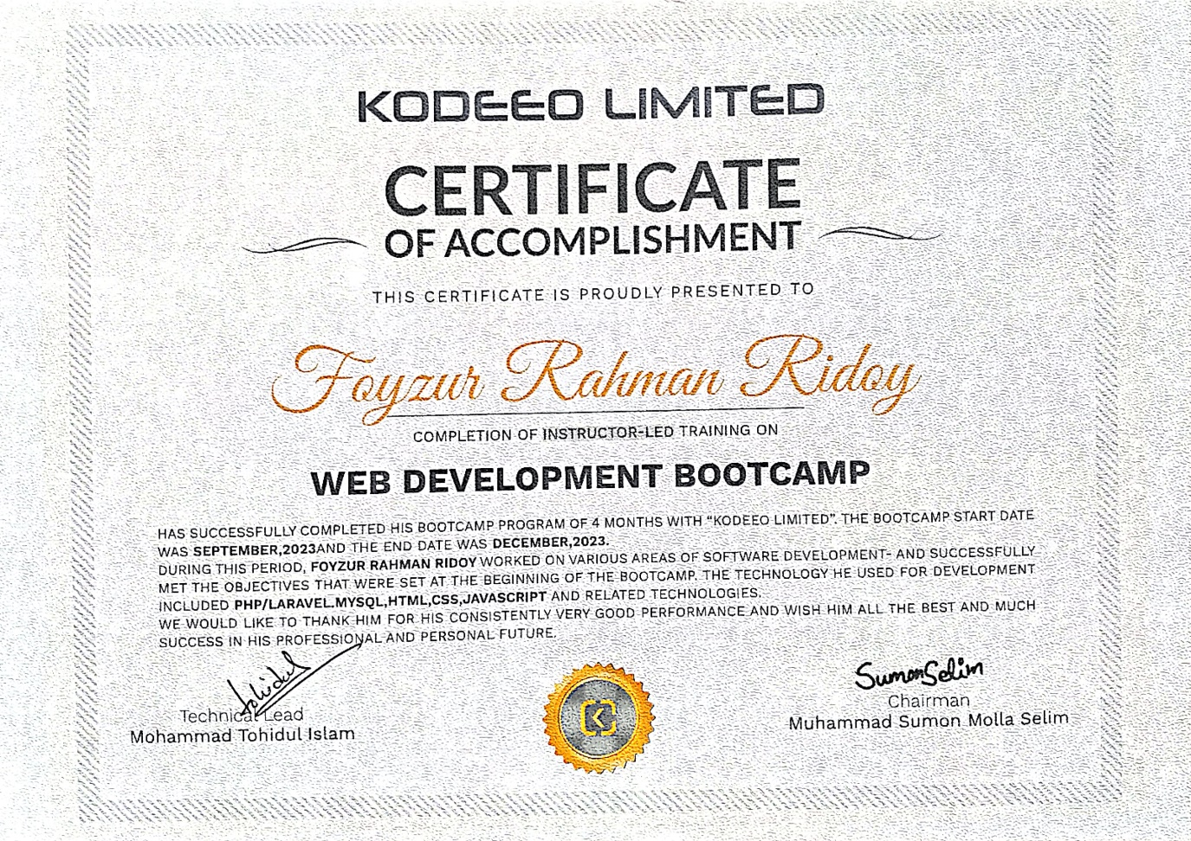

## **Student’s Declaration**

I am Foyzur Rahman Ridoy, bearing ID#20103197, student of BCSE - Bachelor of Computer Science and Engineering program, under the College of Engineering and Technology (CEAT) of IUBAT - International University of Business Agriculture and Technology declaring that, this report on the topic of **“Tourism Management System”** has been prepared for the fulfillment of the internship CSC 490, Practicum as well as the partial requirement of BCSE-Bachelor of Computer Science and Engineering degree.

I am the author of the report and project on the "Tourism Management System". This project's modules and processes were created following thorough research on the internet.

There are no other uses, prizes, or presentations for which it has been prepared.

_____________

Foyzur Rahman Ridoy

ID# 20103197

Program: BCSE

## **Supervisor’s Certification**

For the purpose of certifying that the practicum report on “Tourism Management System” has been executed by Foyzur Rahman Ridoy bearing ID#20103197 of IUBAT – International University of Business Agriculture and Technology as a partial completion of the obligation of practicum defense course. The report, which was created with my assistance, serves as a summary of the successfully completed task. No portions of this report have, to the best of my knowledge and according to his assertion, been submitted anywhere for any degree, diploma, or certification.

He can submit the report at this point. I hope he succeeds in everything he does moving forward.

_______________________________

Md. Rawnak Saif Adib

Supervisor and Lecturer

Department of Computer Science and Engineering

IUBAT–International University of Business Agriculture and Technology

## **Departmental Certification**

On behalf of the Department of Computer Science and Engineering of International University of Business Agriculture and Technology (IUBAT) we, the undersigned, certify that this practicum report **“Tourism Management System”** for the award of Bachelor of Computer Science and Engineering (BCSE) degree was duly presented by Foyzur Rahman Ridoy (ID #20103197) and accepted by the department.

_____________________________

Prof. Dr. Utpal Kanti Das

Chairman and Professor

Department of Computer Science and Engineering

IUBAT – International University of Business Agriculture and Technology

_____________________________

Rashedul Islam

Co-supervisor, Coordinator and Assistant Professor

Department of Computer Science and Engineering

IUBAT – International University of Business Agriculture and Technology

_____________________________

Md. Rawnak Saif Adib

Supervisor and Lecturer

Department of Computer Science and Engineering

IUBAT – International University of Business Agriculture and Technology

## **Abstract**

Imagine planning your dream vacation made easy – that's what the Tourism Management System (TMS) is all about. In this report, we introduce a user-friendly system that transforms the way travel packages are created and experienced. TMS is a user-friendly platform that reimagines the creation and enjoyment of travel packages. For administrators, the system offers a hassle-free environment for crafting travel packages. They can effortlessly input crucial details like hotel information, transport specifics, set prices, and infuse life into packages with engaging descriptions. It's a one-stop-shop for assembling the perfect travel itinerary. On the flip side, tourists benefit from a straightforward interface within TMS. This interface empowers them to explore a variety of travel packages and choose the one that resonates with their preferences. It's like having a personal travel concierge at your fingertips.

Once a tourist selects a package, the adventure begins. TMS allows tourists to put their personal stamp on the trip by customizing details such as food menus, hotel room types, and quantities. This level of personalization ensures that every journey is uniquely tailored to individual tastes and desires. The true beauty of TMS lies not only in its user-friendliness but also in its game-changing capabilities. The system facilitates seamless communication between administrators and tourists, turning what was once a complicated process into a breeze. Through the integration of cutting-edge technology, TMS not only streamlines tourism management but also injects a sense of personalization and joy into every traveler's experience. This report provides an in-depth exploration of TMS, highlighting its key features and demonstrating how it simplifies the traditionally complex world of travel planning. With TMS, we're not just talking about redefining travel; we're ushering in an era of stress-free, personalized, and ultimately satisfying tourism experiences. Say goodbye to the headaches of trip planning and embrace the era of effortless travel with the Tourism Management System.

## **Acknowledgments**

I want to express my heartfelt appreciation for the invaluable blessings bestowed by the Almighty, without which none of this would be possible. Gratitude fills me as I extend my sincerest thanks to my esteemed supervisor, Md. Rawnak Saif Adib, Lecturer from the Department of Computer Science and Engineering at the International University of Business Agriculture and Technology (IUBAT). Their guidance, encouragement, and unwavering support, investing precious time in reviewing and evaluating this work, have been truly inspiring. I am very grateful to the Department of Computer Science and Engineering (CSE) of IUBAT— International University of Business Agriculture and Technology for providing their all-out support during the work. Specially I would like to thank to our Coordination Rashedul Islam, Department of Computer Science and Engineering.

My heartfelt appreciation goes to my parents and classmates, whose unwavering encouragement and assistance have been an invaluable support throughout this journey.

**Table of Contents**

**Letter of Transmittal** iii

**Organization Certificate** iv

**Student’s Declaration** v

**Supervisor’s Certification** vi

**Departmental Certification** vii

**Abstract** viii

**Acknowledgments** ix

**List of Figures** xv

**List of Tables** xvii

**Chapter 1** 1

**Introduction** 1

**1.1 Introduction** 2

**1.2 Background of Study** 3

**1.3 Methodologies** 3

1.3.1 Primary Sources 4

1.3.2 Secondary Sources 4

**1.4 Objectives** 5

1.4.1 Broad Objective 6

1.4.2 Specific Objective 6

**1.5 System Benefit** 6

**1.6 Proposed Model** 7

**1.7 Reason for choosing Incremental Process Model** 7

**1.8 Feasibility Study** 8

1.8.1 Technical Feasibility 8

1.8.2 Economical Feasibility 9

1.8.3 Operational Feasibility 9

**Chapter 2** 10

**Organizational Overview** 10

**2.1 Organizational Overview** 11

**2.2 Mission** 12

**2.3 Vision** 12

**2.4 Organization Services** 12

2.4.1 Website Development 13

2.4.2 Software Development 13

**2.5 Organization Location** 14

**2.6 Address of Office** 15

**Chapter 3** 16

**Requirement Engineering** 16

**3.1 Requirement Analysis** 17

**3.2 Requirement Engineering** 17

3.2.1 User Requirements 17

3.2.2 User Requirements 19

3.2.3 Functional Requirements 20

3.2.4 Non-Functional Requirements 21

3.2.5 Hardware Requirements 21

3.2.6 Software requirement 21

**3.3 Use Case diagram of the system** 22

3.3.1 Use Case diagram of the system 22

**3.4 Use Case Diagram** 25

**Chapter 4** 26

**Analysis Modeling** 26

**4.1 Activity Diagram** 27

4.1.1 Activity Diagram for Admin 27

4.1.2 Activity Diagram for Tourist 28

**4.2 Swim Lane Diagram** 28

4.2.1 Swim Lane Diagram for the System 28

**Chapter 5** 30

**Risk Management** 30

**5.1 Risk Engineering** 31

5.1.1 Stages of Risk. 31

5.1.2 Categories of Risk 34

**5.2 Risk Analysis** 35

**5.3 Risk Planning** 37

**5.4 Risk Monitoring** 38

**5.5 The RMMM Plan** 38

**Chapter 6** 46

**Project Planning and Scheduling** 46

**6.1 Project Planning** 47

**6.2 Project Estimation** 47

**6.3 Function Oriented Matrices** 48

**6.4 Function Point Estimation** 51

**6.5 Identifying Transaction Complexity** 53

**6.6: Identifying Data Complexity** 55

**6.7 Unadjusted Function Point Contribution (Transition Function)** 55

**6.8 Unadjusted Function Point Contribution (Data Function)** 57

**6.9 Performance and environmental impact** 58

**6.10 Counting Adjusted Function Points** 58

**6.11 Details Effort Distribution** 59

**6.12 Project Schedule Chart** 61

**Chapter 7** 62

**Designing** 62

**7.1 Data Flow Diagram** 63

7.1.1 Context Level Diagram 63

7.1.2 Level 1 DFD 64

7.1.3 Level 2 Process 1 Data Flow Diagram 65

7.1.4 Level 2 Process 2 Data Flow Diagram 65

7.1.5 Level 2 Process 3 Data Flow Diagram 66

7.1.6 Level 2 Process 4 Data Flow Diagram 66

**7.2 Entity Relationship Diagram** 67

**7.3 Database** 68

**Chapter 8** 76

**Quality Assurance** 76

**8.1 System Quality Management** 77

8.1.1 System Quality Management Process 78

**8.2 System Testing** 79

8.2.1 System Testing Methodology 79

**8.3 System Testing Design** 80

**Chapter 9** 83

**Conclusion** 83

**9.1 Project limitation** 84

**9.2 Future work** 84

**9.3 Conclusion** 84

**References** 86

## **List of Figures**

Figure 1.1 Incremental Process Model. 7

Figure 2.1 Organization Location Map (Google Maps, 2023) 14

Figure 3.1 Use case diagram symbol 22

Figure 3.2 Actor Symbol 22

Figure 3.3 Use Case Symbol 23

Figure 3.4 Association symbol 23

Figure 3.5 Include Symbol 24

Figure 3.6 Extends Symbol. 24

Figure 3.7 Use Case Diagram. 25

Figure 4.1 Activity Diagram for Admin. 27

Figure 4.2 Activity Diagram for Tourist. 28

Figure 6.1 Effort Distribution Chart. 60

Figure 6.2 Project Schedule Chart. 61

Figure 7.1 Context Level DFD 63

Figure 7.2 Level 1 DFD 64

Figure 7.3 Level 2 Process 1 65

Figure 7.4 Level 2 Process 2 65

Figure 7.4 Level 2 Process 2 65

Figure 7.5 Level 2 Process 3 66

Figure 7.6 Level 2 Process 4 66

Figure 7.7 ER Diagram 67

Figure 7.8 Database for Package 68

Figure 7.9 Database for Tourist Booking List 68

Figure 7.12 Database for Hotel Info 68

Figure 7.11 Database for Transport Info 68

Figure 7.10 Database for User Info 68

Figure 7.13 Admin Dashboard 69

Figure 7.14 Admin Login 69

Figure 7.15 Admin Create Package 70

Figure 7.16 Admin Create Hotel Info 70

Figure 7.17 Admin Create Transport Info 71

Figure 7.18 Tourist Booking List 71

Figure 7.19 Registration form for Tourist 72

Figure 7.20 Login for Tourist 72

Figure 7.21 Tourist Profile 73

Figure 7.22 Tourist Update Profile and Password 73

Figure 7.23 Home Dashboard 73

Figure 7.24 Our Package 74

Figure 7.25 Payment 74

Figure 7.26 Tourist Reservation Form 75

## **List of Tables**

Table 5.2: Risk Analysis 35

Table 5.3: Risk Planning 37

Table 5.3 Project Risk (PR01) 39

Table 5.4 Project Risk (PR02) 39

Table 5.5 Project Risk (PR03) 40

Table 5.7 Technical Risk (TR02) 41

Table 5. 8 Technical Risk (TR03) 42

Table 5. 9 Business Risk (BR01) 43

Table 5.10 Business Risk (BR02) 43

Table 5.11 Business Risk (BR03) 44

Table 5.12 Business Risk (BR03) 45

Table 6.1 Complexity Matrix 50

Table 6.2 Complexity Matrix 50

Table 6.3 Function Point (Admin) 51

Table 6.5 Function Point (Tourist) 52

Table 6.6 Identifying Complexity (Transaction function) 53

Book Package (EI) 53

Manage Hotel Information (EI) 54

Manage Transport Information (EI) 54

Manage Room Types (EI) 54

Manage Food Menu (EI) 54

View Booking History (EQ) 54

Update Tourist Profiles (EI) 54

Search for Package Details (EQ) 54

Report Generation (EO) 54

Table 6.7 Identifying Complexity (Data function) 55

Table 8.1 System Testing Scenario 1 80

Table 8.2 System Testing Scenario 2 80

Table 8.3 System Testing Scenario 3 81

Table 8.4 System Testing Scenario 4 81

Table 8.5 System Testing Scenario 5 81

Table 8.6 System Testing Scenario 6 82

## **Chapter 1**

## **Introduction**

#### **1.1 Introduction**

In an era characterized by dynamic global travel patterns and an increasing demand for personalized experiences, efficient Tourism Management Systems play a pivotal role in orchestrating seamless interactions between tourists and the diverse array of services that define their travel experiences. The following report provides an in-depth analysis of a comprehensive Tourism Management System project, designed to empower administrators in creating customized travel packages while offering tourists an intuitive platform to explore, select, and tailor their travel itineraries. The practicum work presented here is a culmination of extensive research, analysis, and development efforts aimed at addressing the evolving needs of the tourism industry. The project revolves around the creation of a robust Tourism Management System, providing both administrators and tourists with a user-friendly interface and an array of features to enhance the overall travel experience. The tourism industry has witnessed unprecedented growth in recent years, with travelers seeking not just destinations, but immersive and tailored experiences. As a response to this evolving landscape, the Tourism Management System was conceived to bridge the gap between service providers and tourists, streamlining the process of package creation and customization. Traditional methods of booking often fall short in meeting the dynamic preferences of modern travelers, necessitating a more adaptive and comprehensive solution. The significance of this practicum work lies in its ability to revolutionize the way travel-related services are managed and experienced. By offering administrators the tools to craft well-structured packages encompassing hotel details, transport information, pricing, and comprehensive descriptions, and by empowering tourists to personalize their journeys through customizable options such as food menus and hotel room preferences, the system addresses the diverse and intricate requirements of contemporary travelers. This Tourism Management System not only simplifies the workflow for administrators but also enhances the overall customer satisfaction by placing control in the hands of the tourists, allowing them to curate their travel experiences with ease and precision. As the tourism industry continues to grow, the need for adaptable and efficient systems becomes paramount, and this practicum work is a strategic step toward fulfilling that need.

#### **1.2 Background of Study**

The intricate and globally influential nature of the tourism industry demands a sophisticated solution, and this Practicum Report on a Tourism Management System (TMS) stems from the recognition of various challenges facing the sector. From the complexities of reservations to the intricacies of customer interactions, the current operational landscape requires a systematic overhaul. The proposed TMS is designed to be a transformative force, seeking to enhance overall operational efficiency, elevate the quality of customer experiences, and minimize the prevalence of manual errors. An examination of existing systems reveals gaps that have prompted the necessity of such an innovative approach. Incorporating cutting-edge technological trends, including artificial intelligence and data analytics, this TMS is poised not only to meet the current needs of the industry but also to set a new standard for tourism management. Beyond its technological prowess, the significance of this practicum project extends to its potential impact on the growth and sustainability of businesses within the tourism sector. The report's scope is defined by a meticulous consideration of specific functionalities while acknowledging the inherent limitations and constraints involved. Ultimately, this practicum represents a pioneering effort to not only address existing challenges but also to underscore the indispensable role of technology in shaping the future trajectory of tourism management.

#### **1.3 Methodologies**

The methodology for the practicum report on the Tourism Management System (TMS) is designed to be comprehensive and systematic, ensuring the successful development and implementation of an innovative solution. It begins with a thorough requirements analysis, engaging stakeholders to understand their needs, followed by an extensive literature review to incorporate insights from existing technologies and best practices in tourism management systems. The project will employ prototyping as an iterative tool for refinement before moving into the development phase, emphasizing scalability and adherence to coding best practices. Rigorous testing, including unit, integration, and user acceptance testing, will guarantee the functionality, usability, and security of the TMS. The deployment phase will be carefully executed, complemented by user training sessions and detailed documentation to facilitate seamless adoption. The evaluation phase will assess the TMS against predefined objectives, with user feedback informing continuous improvement. Post-deployment, a robust maintenance and support strategy will be implemented, ensuring the system's adaptability to evolving industry needs. This holistic and structured approach aims to deliver a sophisticated TMS that not only addresses current challenges but also lays the foundation for future advancements in tourism management.

##### 1.3.1 Primary Sources

Primary sources for the practicum report on the Tourism Management System (TMS) will predominantly comprise direct interactions and engagements with key stakeholders in the tourism industry. In-depth interviews with tourism managers, frontline staff, and end-users will be conducted to extract firsthand insights into their specific needs, challenges, and expectations from the proposed system. Surveys and questionnaires may also be employed to gather quantitative data on user preferences and requirements. Additionally, observational studies will be conducted within tourism management settings to grasp the nuanced workflows and operational dynamics. Through direct involvement and participation, these primary sources will offer authentic and real-time information crucial for tailoring the TMS to the unique demands of the tourism industry, ensuring that the system is not only technologically sound but also intimately aligned with the practical realities of daily operations.

##### 1.3.2 Secondary Sources

Secondary sources for the practicum report on the Tourism Management System (TMS) will encompass a comprehensive review of existing literature, scholarly articles, industry reports, and relevant case studies related to tourism management systems and information technology in the tourism sector. Academic databases, such as JSTOR and IEEE Xplore, will be explored to gather insights into established frameworks, methodologies, and best practices in the development and implementation of similar systems. Industry reports from tourism organizations, technology companies, and market research firms will be examined to understand current trends, challenges, and innovations in tourism management. Moreover, online platforms, official documentation, and white papers from software providers and industry associations will be scrutinized to gain a holistic understanding of the technological landscape and emerging solutions. This synthesis of secondary sources will contribute a theoretical foundation and industry context to the practicum report, enriching the project's methodology and reinforcing its alignment with existing knowledge and advancements in the field.

#### **1.4 Objectives**

The project focuses on the development of a comprehensive Tourism Management System (TMS) with the overarching objective of facilitating a user-friendly ecosystem where administrators can dynamically create and manage tourism packages while offering tourists a seamless booking experience. The system's first objective is to empower administrators with tools to efficiently craft diverse packages, encompassing various elements such as transportation, accommodation, attractions, and activities. This involves implementing a robust admin interface where package details, pricing structures, and itinerary specifics can be easily configured and updated. Simultaneously, the TMS aims to provide tourists with a user-centric platform, enabling them to browse through a catalog of meticulously crafted packages, each with detailed descriptions, images, and pricing information. The booking process is designed to be intuitive, allowing tourists to select preferred packages, customize options if available, and proceed with a straightforward booking process. The overarching goal is to enhance user satisfaction by providing a hassle-free and transparent booking experience. By implementing secure and efficient payment processing functionalities, the TMS seeks to ensure the accuracy of financial transactions and maintain the integrity of customer data. Moreover, the system will incorporate features such as real-time availability updates and instant confirmation notifications, contributing to an enhanced level of service for both administrators and tourists. Through these detailed objectives, the practicum project aims to leverage technology to revolutionize tourism management, creating a symbiotic relationship between administrators who curate compelling travel packages and tourists who seek a seamless, personalized, and secure booking experience.

##### 1.4.1 Broad Objective

At the board level, the objectives for the Tourism Management System (TMS) practicum project are centered on fostering innovation, operational efficiency, and customer satisfaction. The board aims to guide the development of a cutting-edge TMS that enhances competitiveness, contributes to revenue growth, and positions the organization as a leader in tourism management. Key priorities include empowering administrators to create and manage diverse tourism packages and ensuring a user-centric approach for a seamless and technologically optimized booking experience. The overall goal is to drive strategic value and advance the organization's standing in the tourism industry.

##### 1.4.2 Specific Objective

The specific objectives of the Tourism Management System (TMS) practicum project include developing a scalable TMS for administrators to create and manage diverse tourism packages efficiently. This involves providing administrators with an intuitive interface for customizing package details. Simultaneously, the project aims to design a user-friendly platform for tourists to seamlessly browse, select, and book packages, enhancing the overall efficiency and satisfaction in the tourism management process.

#### **1.5 System Benefit**

The Tourism Management System (TMS) offers a myriad of benefits, streamlining and enhancing various facets of the tourism industry. Administratively, the system facilitates efficient package creation, enabling administrators to customize offerings, set pricing, and manage itineraries seamlessly. This not only reduces the time and effort required for administrative tasks but also ensures accuracy and consistency in package details. For tourists, the TMS provides a user-friendly interface for browsing, selecting, and booking packages, offering a streamlined and intuitive booking process. Real-time availability updates, instant confirmation notifications, and secure payment processing contribute to an improved customer experience. Overall, the TMS optimizes operational processes, reduces manual intervention, and fosters a dynamic and responsive environment for both administrators and tourists, ultimately elevating the efficiency and effectiveness of tourism management.

#### **1.6 Proposed Model**

When it comes to software, there are times when the needs of the user are clear-cut, yet the software is sometimes needed right away. An effective solution in this situation is the incremental process paradigm. With this approach, software can be released piecemeal. Future software updates may increase the software's capability. The software is available for usage, and users can comment on 10 its functionality. Development and upkeep are both 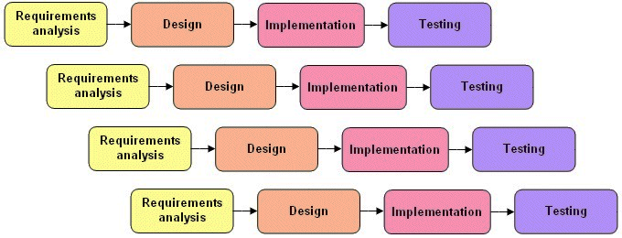involved. Once it satisfies all requirements, a product is considered done.

Figure 1.1 Incremental Process Model.

#### **1.7 Reason for choosing Incremental Process Model**

The adoption of the Incremental Process Model for the implementation of the Tourism Management System is driven by its iterative and phased approach, offering a systematic progression from fundamental functionalities to more sophisticated features. The model commences with the identification and development of essential features such as booking and reservation management, basic user profiles, and itinerary tracking. Subsequent iterations build upon this foundation by gradually introducing additional features, including personalized travel itineraries, real-time availability updates, and enhanced customer communication tools. The model's inherent flexibility proves advantageous, allowing for modifications and additions based on evolving requirements and feedback collected during each iteration. This adaptability ensures that the system remains responsive to the dynamic needs of the tourism industry and incorporates technological advancements seamlessly. Moreover, the Incremental Model helps mitigate development risks by breaking down the project into manageable units, facilitating early testing and deployment of critical functionalities. This approach yields tangible outcomes, encouraging stakeholder involvement and ongoing feedback for continuous improvements. In summary, the Incremental Process Model aligns seamlessly with the development of the Tourism Management System, providing a methodical and phased strategy for continuous refinement, evolution, and effective responsiveness to the diverse needs of users and the objectives of the tourism industry.

#### **1.8 Feasibility Study**

A feasibility study is essential for assessing the practicality of implementing a new system within a company. It determines the potential benefits of the proposed tasks and whether they align with the organization's objectives. The evaluation of system automation revolves around three critical dimensions to establish its viability:

* Technical Feasibility
* Economic Feasibility
* Operational Feasibility

##### 1.8.1 Technical Feasibility

The technical feasibility of the project hinges on the proficiency of the development team and potential challenges related to hardware capabilities, reliability, and availability. After thorough evaluation, I have concluded that the concept is theoretically feasible, as the envisioned model can be constructed using the outlined components. The project will utilize XAMPP as the development environment, and the implementation requires proficiency in high-level programming languages such as HTML, CSS, Bootstrap, or PHP's Laravel Framework. The essential tools, including a server for the database, an Integrated Development Environment (IDE) like Sublime Text or VS Code, and a cloud server for data preservation, are readily available and accessible. These technologies, coupled with basic computing devices such as computers or smartphones, ensure the technical feasibility of our strategy.

##### 1.8.2 Economical Feasibility

The financial feasibility of implementing a new system assesses its cost-effectiveness. The proposed program for a tourism management system is economically viable due to its streamlined requirements. Only one operating system, one Integrated Development Environment (IDE), and one browser are needed, resulting in reduced costs. Furthermore, the transition to a digital platform will significantly decrease paper costs. The system's reliance on a centralized database for storing information ensures efficient data management. From the customer's perspective, minimal information input is required for tasks such as booking, scheduling, and payment checks. Importantly, the tourism management system won't necessitate ongoing contributions from establishments to maintain its operations. Considering these factors, the program is deemed financially feasible.

##### 1.8.3 Operational Feasibility

The Tourism Management System demonstrates operational feasibility with its user-friendly design, requiring minimal training for broad user acceptance. It seamlessly integrates with existing operations, gaining support from users and management alike. The system's accessibility for website members through a straightforward login process enhances practicality. Its alignment with organizational entities and external environments ensures operational feasibility at both user and managerial levels in the tourism management framework, promoting widespread acceptance.

## **Chapter 2**

## **Organizational Overview**

#### **2.1** **Organizational Overview**

Kodeeo Limited is a trailblazer in the technology sector, known for its cutting-edge software solutions and customized development services. Specializing in web development, mobile app creation, software development, ERP solutions, and domain hosting, Kodeeo's impressive portfolio includes successful projects like Wabmart, Pharmacy Digital License Management (LRS), Digital Project Management (PMS), and more. The company not only excels in delivering impactful solutions but also hosts educational bootcamps, covering diverse topics such as web development, graphic design, mobile app development, and software quality assurance. Prioritizing client satisfaction and interactive learning experiences, Kodeeo is committed to transforming ideas into tangible solutions and empowering individuals through its educational platform. The company's dedication to value creation, collaborative engagement, and knowledge fostering reflects its commitment to realizing clients' visions in the dynamic landscape of technology. (Kodeeo, 2023)

Nestled in the heart of sector 10, Uttara, Dhaka, Bangladesh, Kodeeo Limited is a hub of passion for exceptional design and a steadfast commitment to serving small businesses. Operating within a compact setup, the Kodeeo Limited team personifies resilience, creativity, and an unwavering dedication to excellence. Our fervor for our craft propels us to exceed expectations in meeting the diverse requirements of our clients. With a robust client base, our expertise spans across diverse domains, including software development, data analytics, content creation, meticulous quality assurance, business intelligence, cloud-based solutions, IoT integration, server maintenance, and adept IT consulting services. At Kodeeo Limited, we pride ourselves on our ability to blend innovation with dedication, ensuring that our clients receive unparalleled solutions tailored to their unique needs.

#### **2.2 Mission**

Kodeeo Limited is on a mission to shape innovative and purpose-driven software solutions that empower businesses, resonate with users, and drive growth in today's dynamic digital landscape. We are committed to unlocking the full potential of technology by crafting intuitive, efficient, and reliable applications that address the distinctive needs of our clients. Our overarching goal is to be a trusted partner in facilitating digital transformation, utilizing cutting-edge tools and methodologies to deliver impactful software solutions. We foster a culture of creativity, collaboration, and continuous learning within our team, ensuring that we stay ahead in the ever-evolving technological landscape. Through our unwavering dedication and expertise, we aspire to make meaningful contributions to our clients' success and remain at the forefront of technological innovation.

#### **2.3 Vision**

Kodeeo Limited envisions leading a technological revolution through pioneering solutions that redefine industry standards and transform businesses on a global scale. Our vision encompasses a future where our cutting-edge software and digital advancements seamlessly integrate into everyday life, fostering efficiency, accessibility, and empowerment. We aspire to be acknowledged as trailblazers in the tech industry, contributing to a world where technology bridges gap, enhances experiences, and unlocks new possibilities for both businesses and individuals. Committed to continual innovation, collaboration, and excellence, we strive to set new benchmarks and inspire the next wave of digital evolution. Kodeeo Limited's vision is grounded in the belief that technology can be a powerful force for positive change, shaping a future where possibilities are limitless and the impact is transformative.

#### **2.4 Organization Services**

The organization services include:

* Website development
* Software development

##### 2.4.1 Website Development

At Kodeeo Limited, our emphasis lies in crafting visually engaging, aesthetically pleasing, and meticulously planned website designs. We understand the pivotal role a remarkable website plays in establishing a robust online presence and capitalizing on the multitude of advertising avenues the internet offers. Our team initiates a competitive edge in website design, meticulously considering crucial elements such as user-friendly navigation, overall coherence and content excellence, adhering to stipulated timelines and budgets, and ensuring backend functionalities are optimized.

##### 2.4.2 Software Development

Kodeeo Limited offers highly responsive, fully dynamic, and customized software solutions tailored for companies, businesses, and individuals worldwide. Our adept professionals possess the expertise to design software solutions that enhance efficiency and simplify everyday tasks, ensuring a seamless experience in your daily operations.

#### **2.5 Organization Location**

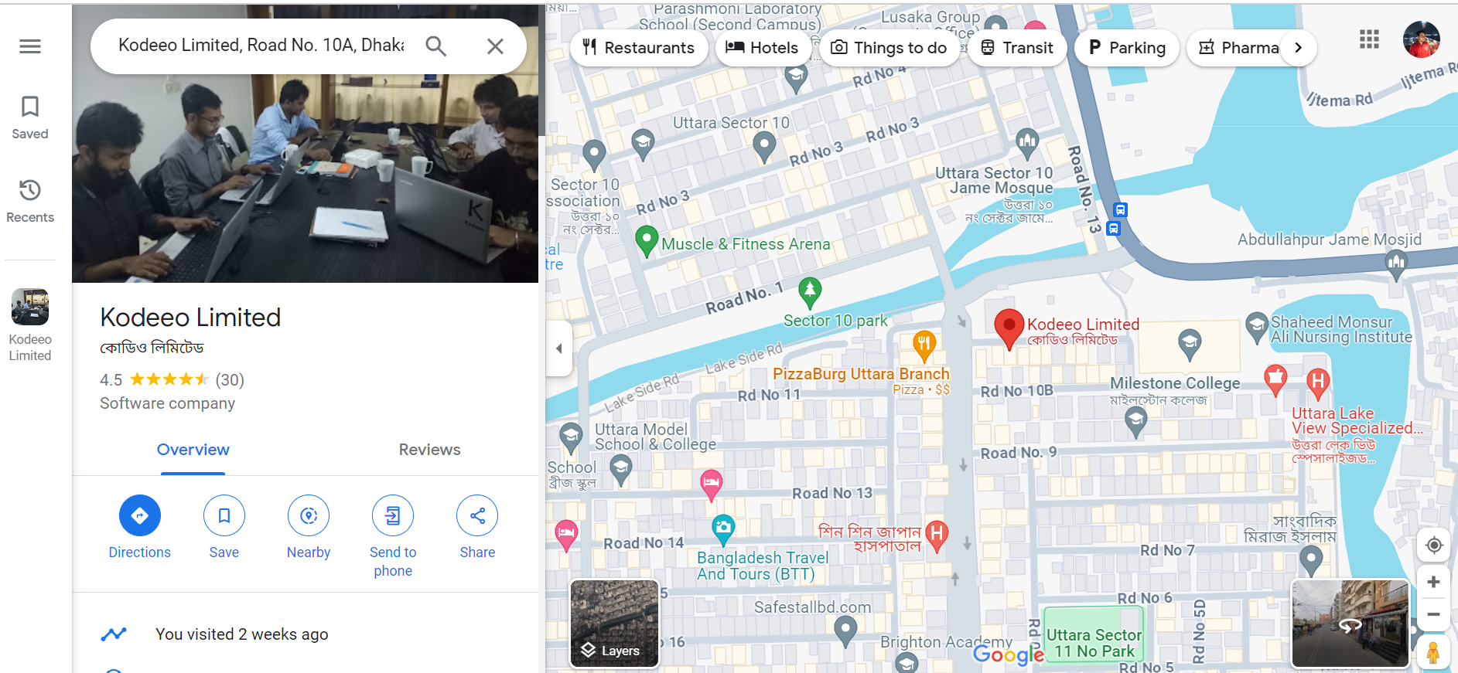

Figure 2.1 Organization Location Map (Google Maps, 2023)

#### **2.6 Address of Office**

🏢 Kodeeo Limited Office Address:

House #15, Road #10/A,

Sector #11, Uttara,

Dhaka-1230, Bangladesh

Feel free to reach out to us at:

📞 Call Us: 01854969657

📧 Email: info@kodeeo.com

🌐 Website: www.kodeeo.com

## **Chapter 3**

## **Requirement Engineering**

#### **3.1 Requirement Analysis**

In the software engineering process, the requirements analysis phase distinctively separates system engineering and system design. This critical stage empowers software engineers to construct modules for the data, functional, and behavioral domains that will be under the software's control. Through meticulous requirements analysis, software designers gain the ability to visualize the intricacies of the system's data, functionality, and behavior. Serving as the inaugural step in the software development process, requirements analysis involves setting forth the standards essential for a new or modified product, considering the diverse and at times conflicting needs of stakeholders. The project's success hinges on the effectiveness of this requirements analysis, emphasizing the necessity for criteria that are measurable, testable, explicit, and directly aligned with specified business opportunities or needs.

#### **3.2 Requirement Engineering**

Requirements engineering, within the field of engineering, plays a pivotal role in identifying user needs and outlining the specifications for software systems. While there are multiple definitions of requirements engineering, they all converge on a common principle: understanding users' expectations from a computer system and translating those expectations into design requirements. This discipline is intricately connected with software engineering, as both are fundamentally concerned with crafting systems that align with customer desires. In essence, requirements engineering sets the foundation by delineating what users anticipate from a computer system, establishing a crucial link between user expectations and the actual design and development processes in software engineering.

##### 3.2.1 User Requirements

Interface and Accessibility for the Tourism Management System:

* **Intuitive User Interface:** The system ensures a user-friendly interface catering to both administrators and tourists, fostering ease of navigation and accessibility to diverse functionalities.
* **Package Management:** Administrators are equipped with an efficient package creation interface, enabling seamless development, updating, and management, while tourists experience a straightforward booking process for enhanced accessibility to desired travel packages.

Account and Access Management:

* **Accessibility:** Tourists and administrators demand accessibility across various devices (desktop, mobile) and operating systems, ensuring usage flexibility regardless of location or device.
* **Role-Based Access:** Administrators require the capability to assign specific roles and permissions to users, ensuring precise access to functionalities based on their responsibilities in the tourism management system.

Operational and Task Management:

* **Efficient Booking Process:** Tourists seek a streamlined booking feature allowing them to select and reserve packages effortlessly, including options for hotel room types, food menus, and travel details.
* **Travel Itinerary Management:** Administrators need an efficient system for managing travel packages, incorporating hotel information, transport details, pricing, package descriptions, and durations.

Data Viewing and Handling:

* **Comprehensive Dashboard:** Admins require a centralized dashboard to view and manage vital data, encompassing package details, booking information, and performance metrics.
* **Booking Information Access:**  Tourists expect easy access to their booking details, including selected hotel room types, food preferences, and travel arrangements.
* **Task Management:** Tourist expect a platform to view travel package, submit reservation form, and book the package efficiently.

Tour and Travel Management:

* **Seamless Booking Requests:** Tourists seek a straightforward process for submitting, tracking, and managing travel requests, from initial submission to approval and ongoing tracking within the tourism management system.
* Top of Form

##### 3.2.2 User Requirements

1. User Account Management:
   1. Tourist Account Creation:
      1. System Requirement 1.1.1: Provide an "Create Account" option for tourist.
      2. System Requirement 1.1.2: Direct users to a registration form upon selection.
      3. System Requirement 1.1.3: Capture necessary user details such as name, email, and password during registration.
      4. System Requirement 1.1.4: Validate inputs to ensure accuracy and completeness of registration information.
      5. System Requirement 1.1.5: Display a confirmation message upon successful account creation.
2. Authentication and Access Control:

2.1 Authentication Mechanism:

* + 1. System Requirement 2.1.1: Offer secure authentication options including username/password and multi-factor authentication (MFA).
    2. System Requirement 2.1.2: Store user credentials using encryption for enhanced security.

1. Tourist Profile Management:

3.1 Profile Information Handling:

* + 1. System Requirement 3.1.1: Enable tourists to update personal and professional information securely.

1. Booking Management:

4.1 Book Requests:

* + 1. System Requirement 4.1.1: Facilitate book request submissions for tourists.
    2. System Requirement 4.1.2: Allow admins to approve or deny requests promptly.

1. Work Details Viewing:

5.1 Admin Dashboard:

* + 1. System Requirement 5.1.1: Develop an admin dashboard providing access to total packages, total user and total booking list.

##### 3.2.3 Functional Requirements

* **Package Creation:** Admins can create tourism packages, specifying hotel and transport details, room types, and food menus.
* **Package Editing:** Admins can edit existing packages without affecting booked reservations.
* **Package Availability:** Admins set availability dates; system prevents bookings outside specified dates.
* **Package Display:** Tourists view detailed package information, including hotels, transport, room types, menus, and pricing.
* **Package Selection:** Tourists select packages and interactively choose room types and food options.
* **Booking Process:** Tourists securely make payments, receiving detailed booking confirmations.
* **Booking Management:** Admins view and update booking details and statuses.
* **Package Reservation:** Tourists reserve packages with specified duration before final payment.
* **Package Cancellation:** Tourists can cancel within a set period; admins handle cancellations and refunds.

##### 3.2.4 Non-Functional Requirements

* **Performance:** The system must handle a minimum of 1000 concurrent users without significant degradation in response time.
* **Usability:** The user interface should follow UX best practices, ensuring ease of navigation and an intuitive booking process for tourists.
* **Security:** Ensuring data security through encryption, secure login processes, role-based access control, and regular security audits.
* **Reliability:** The system should be reliable, available, and maintainable, with regular backups and redundancy measures to prevent data loss.
* **Scalability:** Capability to accommodate a growing user base and additional functionalities without compromising performance.
* **Compliance:** Adherence to relevant industry standards and regulations regarding data privacy and security.

##### 3.2.5 Hardware Requirements

* **Processor:** Dual-core processor or higher for handling database operations and system functionalities efficiently.
* **RAM:** Minimum 8GB RAM for smooth multitasking and handling concurrent user requests effectively.
* **Storage:** At least 500GB of storage space to accommodate the database, system files, and logs.
* **Network Interface:** Gigabit Ethernet for fast data transfer and network stability.

##### 3.2.6 Software requirement

* Operating System – Windows 10
* Framework – Laravel 8.0
* Frontend – HTML5, CSS3, Bootstrap5, JavaScript, jQuery Database – MySQL Server

#### **3.3 Use Case diagram of the system**

##### 3.3.1 Use Case diagram of the system

Figure 3.1 Use case diagram symbol

**Actor:** When consumers of use cases engage with these use cases, they take on a variety of roles, which are represented by actors. Actors might be automated systems or people.

Figure 3.2 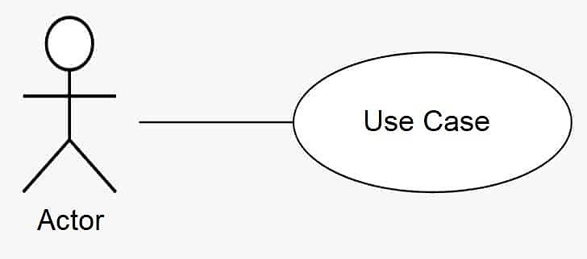Actor Symbol

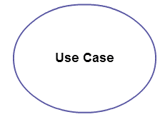**Use case:** A use case depicts a user objective that can be attained by using a system or software program. A use case is the description of a series of system operations that produce an observable result that is typically valuable to one or more system actors.

Figure 3.3 Use Case Symbol

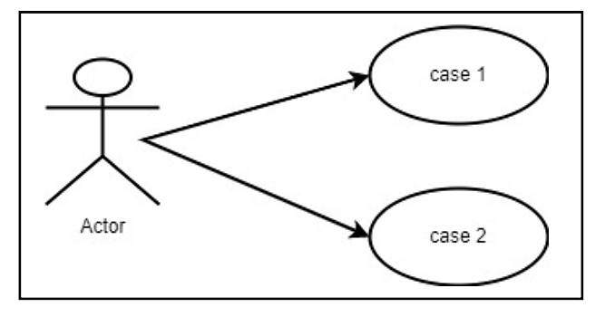**Association:** A use case and an actor can be linked together to show that the actor is involved in that use case. An association, then, is a series of activities that the actors and use case take to accomplish the use case.

Figure 3.4 Association symbol

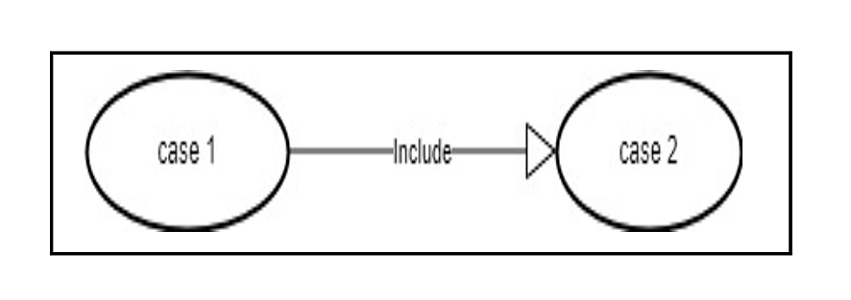**Include:** The inclusion uses case's activity is placed into the base use case's behavior according to the terms of an include relationship.

Figure 3.5 Include Symbol

**Extend:** The behavior defined for the base use case can be put into the behavior defined for the extension use case according to the extend relationship.

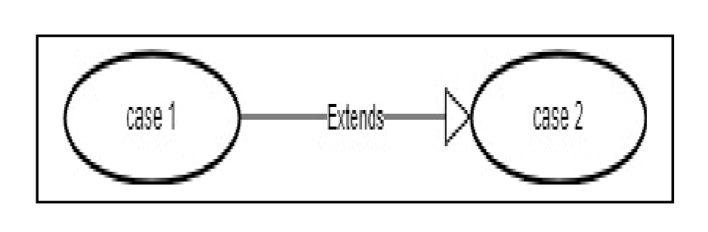

Figure 3.6 Extends Symbol.

#### **3.4 Use Case Diagram**

Tourism Management System

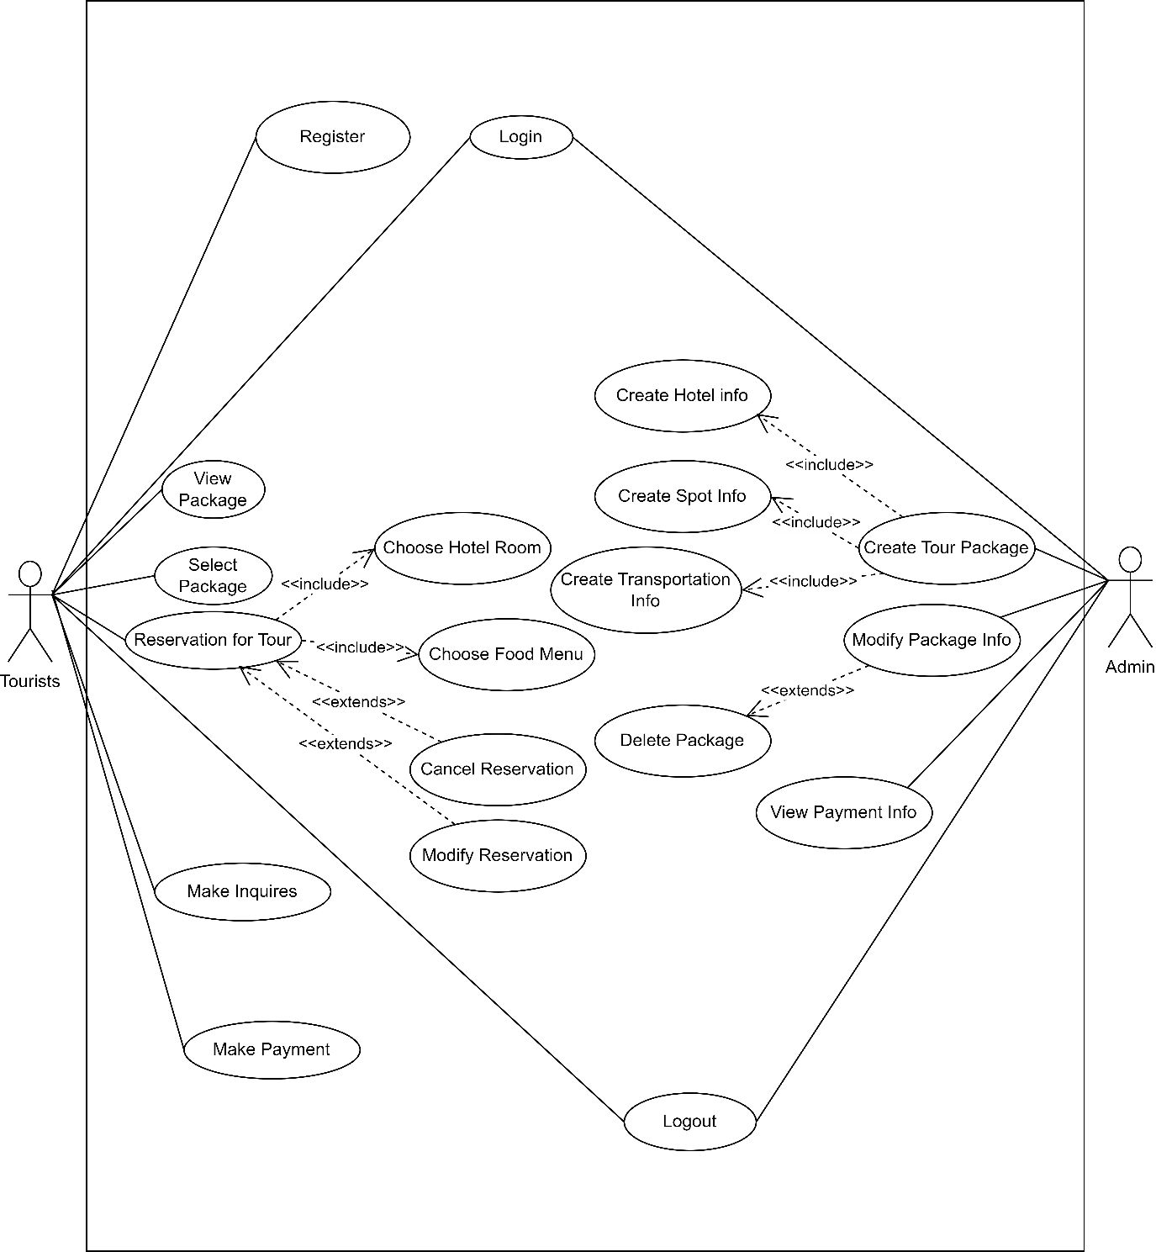

Figure 3.7 Use Case Diagram.

## **Chapter 4**

## **Analysis Modeling**

#### **4.1 Activity Diagram**

##### 4.1.1 Activity Diagram for Admin

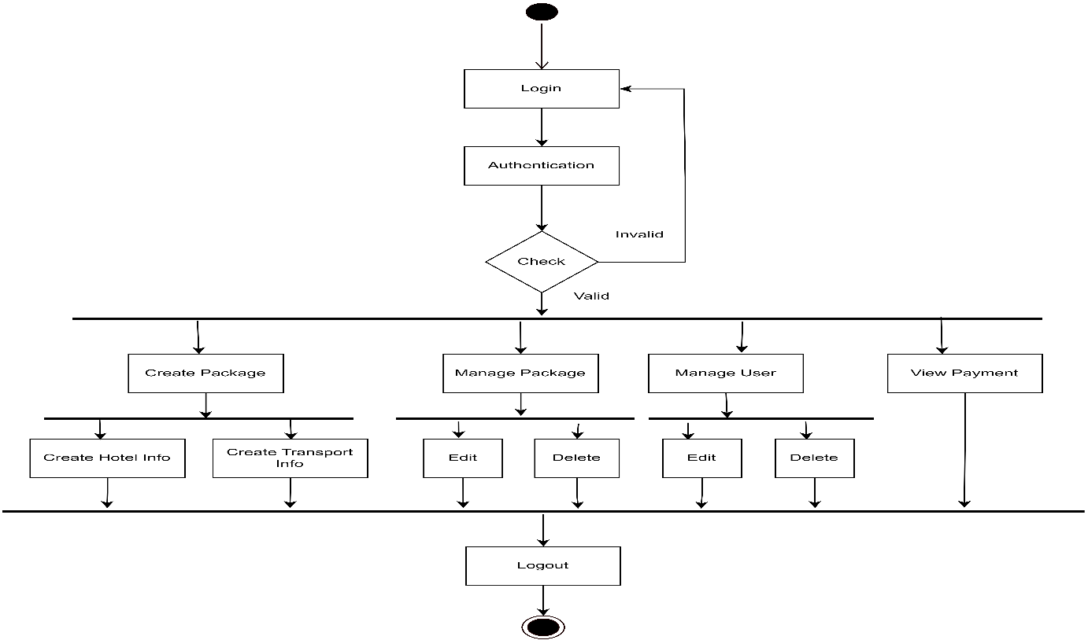

Figure 4.1 Activity Diagram for Admin.

##### 4.1.2 Activity Diagram for Tourist

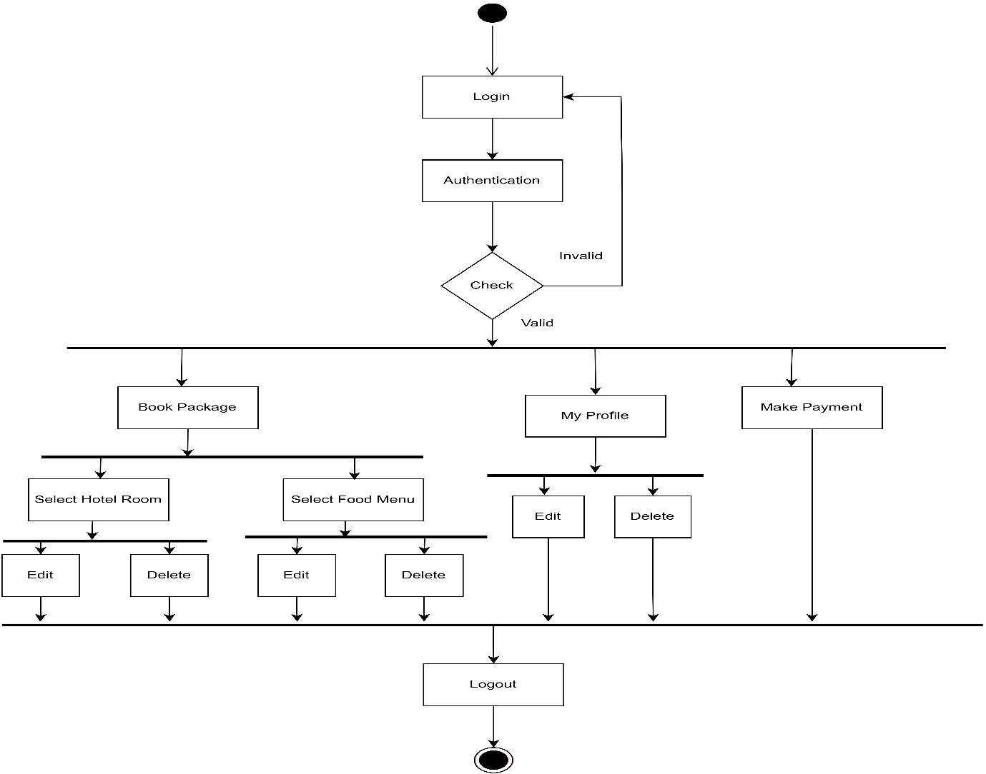

Figure 4.2 Activity Diagram for Tourist.

#### **4.2 Swim Lane Diagram**

##### 4.2.1 Swim Lane Diagram for the System

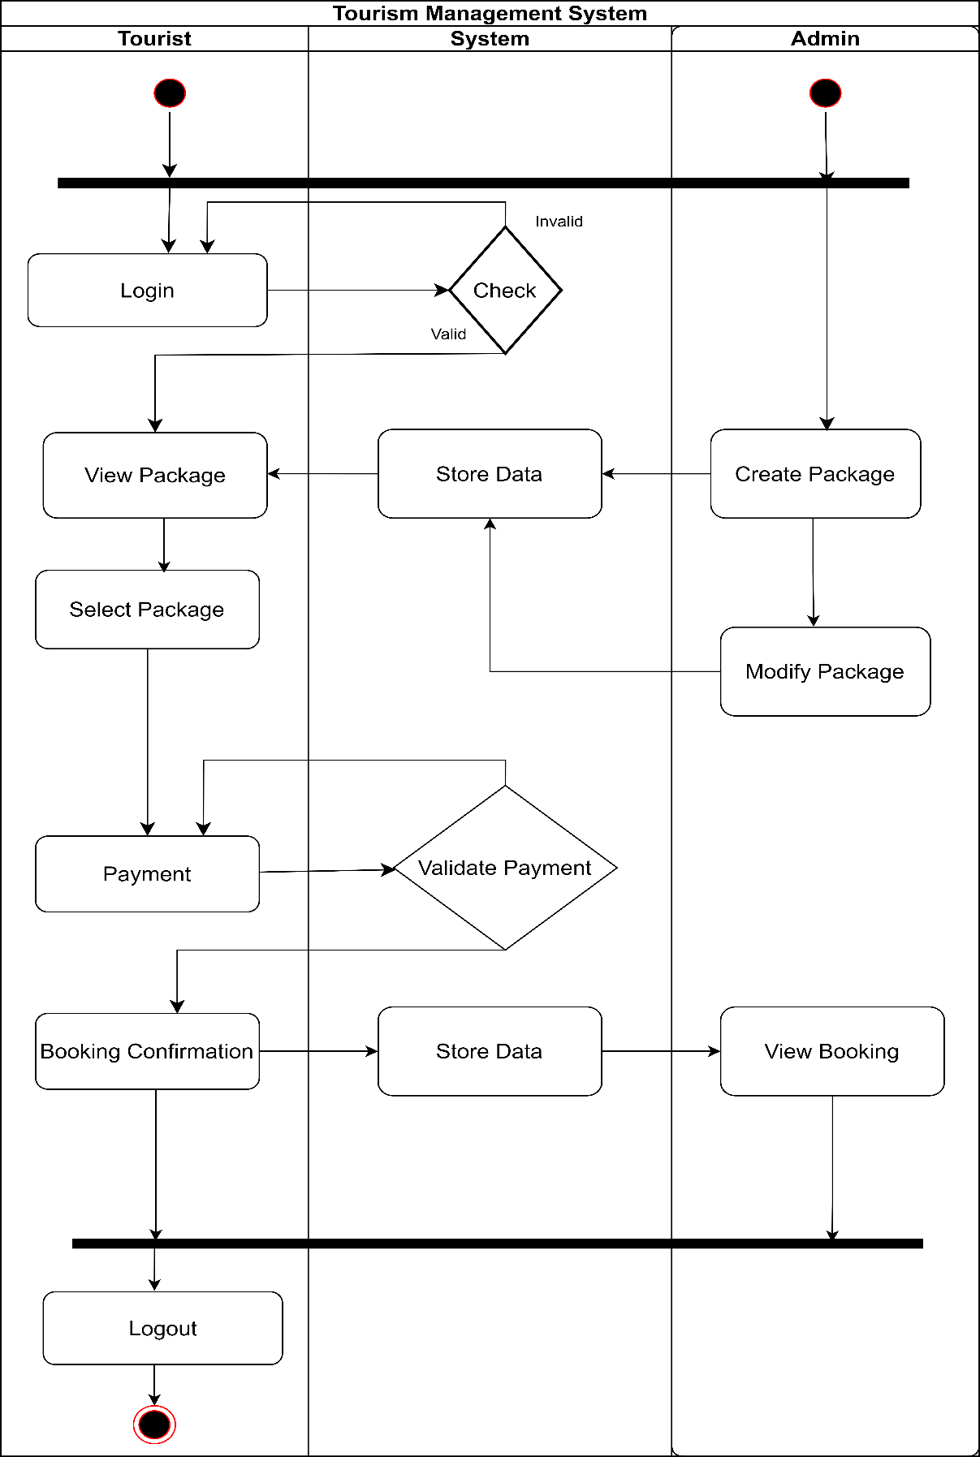Figure 4.3 Swim Lane Diagram.

## **Chapter 5**

## **Risk Management**

#### **5.1 Risk Engineering**

Understanding and navigating uncertainty within a system development team is significantly enhanced through various measures, one of which involves robust risk analysis and management. In the intricate process of system creation, numerous challenges may emerge. Risks, being potential problems, carry an inherent possibility of occurrence or non-occurrence. The comprehensive process of scrutinizing and handling risks encompasses several sequential stages. Initially, risks are identified, followed by an evaluation of the probability of their realization and the magnitude of potential impact. Once this data is established, risks are documented. Subsequently, a tailored strategy is formulated to effectively mitigate the risks with the highest likelihood and consequential impact.

##### 5.1.1 Stages of Risk.

There are different Stages of risk. They are:

* **Risk Identification:** Gathering data stands as a pivotal phase within the risk identification process, aiming to unearth potential risks or hazards. The methodologies and technologies employed for data collection and manipulation exhibit a wide spectrum of diversity. The team amalgamates data through a blend of automated systems and human intervention, embarking on the journey to pinpoint potential risks concerning Web resources. Among the array of methods, web crawling emerges as a valuable technique, offering insights into the landscape of websites and web pages, enriching the data reservoir further.

**Technological Risks**

* 1.1: Platform Issues: Potential problems might arise when using specific platforms (e.g., working on Notepad++ causing occasional issues).
* 1.2: Software Defects: Possibility of defects within the software.
* 1.3: Hardware Problems: Risk of hardware malfunctions.
* 1.4: Database Performance: Database limitations in processing expected transactions per second.

**People Risks**

* 2.1: Health Issues: Possibility of team members falling ill.
* 2.2: Study Leave: Employees taking study leaves impacting project continuity.
* 2.3: Skill Gaps: Employees lacking necessary skills for the project.

**Organizational Risks**

* 3.1: Budget Assurance: Ensuring organizational commitment to provide necessary funds.
* 3.2: Information Accessibility: Confirmation that the organization will supply all project-relevant information.

**Tools Risks**

* 4.1: Tool Suitability: Risk of using incorrect or unsuitable tools.
* 4.2: Insufficient Tools: Inadequate availability of required tools.

**Requirement Risks**

* 5.1: Post-Project Requirements: Potential emergence of new requirements post-project completion affecting the system.
* 5.2: Deadline Constraints: Possibility of receiving requirements that cannot be feasibly implemented within the project deadline.

**Estimation Risks**

* 6.1: Clear Estimations: Ensuring clarity in estimations considering project time duration.
* 6.2: Budget Variance: Possibility of the estimated budget increasing.

**Risk Classification:** The complex task of risk classification involves creating a highly organized model that effectively incorporates visible risk factors and events into its structure. In order to navigate the intricate terrain of potential threats to web pages, websites, and hosting systems, the team utilizes a combination of quantitative and qualitative methods. These strategies act as insightful instruments, carefully pinpointing and classifying a wide range of risks that could impact the digital environment. This ensures a thorough comprehension and proactive handling of potential vulnerabilities.

**Risk Assessment:** Risk assessment is a careful process aimed at identifying significant risk scenarios or sequences of events that could lead to harm or loss, coupled with an evaluation of the probability of these scenarios occurring. In a broader sense, according to Rosenthal, an optimal risk assessment should incorporate qualities such as transparency, coherence, consistency, thoroughness, comprehensiveness, impartiality, uniformity, equilibrium, defensibility, longevity, adaptability, and should be complemented by appropriate and substantial education. This comprehensive approach establishes a sturdy and flexible framework for assessing potential risks, promoting a resilient strategy to effectively mitigate and manage uncertainties.

**Risk Analysis:** The outcomes obtained through a risk analysis form the foundation for assessing both the immediate and subsequent effects of patterns or scenarios, including estimations of future losses and recovery costs. In this all-encompassing procedure, vulnerabilities undergo careful examination, resulting in the development of strategies for mitigation, all while taking into account the organization's willingness to accept risk. This comprehensive method entails the examination of vulnerabilities, the creation of resilient mitigation plans, and the synchronization of these measures with the organization's risk tolerance. This guarantees a proactive approach to handle and reduce potential threats.

**Risk Management Implantation:** The integration of procedures, guidelines, and methodologies used to address and navigate identified risks defines the domain of implementing risk management. The implemented program must delicately weigh the inherent value of assets against the direct and indirect costs linked to either preventing or recovering from potential harm or loss. This balance ensures a practical approach, maximizing resources while protecting against risks, establishing a resilient strategy that protects assets and minimizes potential financial consequences.

Effectively maintaining a web-based system requires taking into account various essential factors:

* **Hardware and Software Configuration:** This includes overseeing updates for operating systems, web servers, and security patches, as well as discontinuing insecure services. The crucial implementation of firewalls and other security measures is essential.
* **Management Procedures:** Renewing registrations for domain names, establishing contracts with reputable service providers, and supervising legal obligations are all part of this responsibility.
* **Network Optimization:** Responsibilities involve load balancing, traffic management, and ongoing monitoring of usage to establish and sustain an efficient network.
* **Backup and Archiving Policies:** Developing thorough protocols for backups and archives, specifying the backup media type, update frequency, the retention period for backups, and secure storage locations.
* **Server Placement and Exposure to Risks:** Evaluating the physical placement of servers and their vulnerability to potential hazards such as fire, floods, earthquakes, electrical system anomalies, power interruptions, temperature variations, theft, and vandalism.

##### 5.1.2 Categories of Risk

In any software project, an array of risk categories warrants careful consideration. In this particular project, the focus encompasses:

* **Project Risks:** These dangers jeopardize the soundness of the project plan, posing a potential risk to timelines and escalating costs if they materialize. They involve issues pertaining to the project's financial plan, deadlines, workforce, resources, client anticipations, and requirements—all of which could influence the project's course.
* **Technical Risks:** These risks pose a threat to both the quality and punctuality of the upcoming software development. If technical risks manifest, implementation may become arduous or unachievable. They encompass potential issues with design, implementation, interface, verification, and maintenance. Additionally, technical risks encompass challenges related to specification ambiguity, technical uncertainty, and the potential obsolescence of technology used.

These outlined categories of risks serve as crucial focal points, guaranteeing a proactive approach to mitigating possible challenges that could influence the project's success. This spans from project management to technical implementation, covering a range of potential pitfalls.

#### **5.2 Risk Analysis**

Table 5.2: Risk Analysis

|  |  |  |
| --- | --- | --- |
| **Risk Analysis** | | |
| **Risk** | **Probability** | **Effects** |
| 1.1: There might be an issue with the platform we are currently using. | Low | Insignificant |
| 1.2: Some hardware problem may arise. | Low | Insignificant |
| 1.3: Software may have some defects. | Low | Insignificant |
| 1.4: The database used in the system cannot process as many transactions per second as expected. | Low | Insignificant |
| 2.1: People may fall in sick. | Moderate | Tolerable |
| 2.2: Staff May go for study leave. | Moderate | Tolerable |
| 2.3: Staff is not skilled about this project. | Moderate | Tolerable |
| 3.1: Prior to commencing the project, it is essential to ascertain that the organization will furnish the necessary funding. | High | Serious |
| 3.2: In order to initiate the project, it is imperative to gather organizational details to ensure that they will provide all the necessary information encompassed within the project. | High | Catastrophic |
| 4.1: Incorrect tools may cause problems. | Low | Insignificant |
| 4.2: Lacking number of tools. | Moderate | Tolerable |
| 5.1: Upon the project's completion, there is a possibility of additional requirements emerging that could impact the entire system. | Low | Tolerable |
| 5.2: Requirement may come which cannot be possible to  build up within deadline. | Low | Insignificant |
| 5.3: Clarity in requirements is essential prior to initiating the project; without it, the work may not be feasible. | High | Serious |
| 6.1: Estimation should be clear because there is time  duration. | Low | Tolerable |
| 6.2: Estimated budget may increase. | Moderate | Tolerable |

#### **5.3 Risk Planning**

Table 5.3: Risk Planning

|  |  |
| --- | --- |
| Risk Planning | |
| Risk | Strategy |
| 2.1: People may fall in sick. | During team collaboration, it's important to allocate additional hours or have extra team members to ensure that the absence of any individual does not impact the project. |
| 2.3: Staff is not skilled about this project. | Prior to commencing the project work, it is crucial to confirm the availability of employees and assess their skills to ensure suitability for the project. |
| 3.1: Prior to initiating the project, it is essential to confirm that the organization will allocate the necessary funds. | The organization might be facing financial constraints and may be unwilling to allocate a budget for the project. |
| 5.1: After complete the project some requirement may come that can affect on whole System. | If requirement is change than it become hard to do the project like when employee working for project then some requirement become change then it becomes harder. |
| 6.3: Resources may not be enough to complete the project. | Back up will be ready with extra resources. |

#### **5.4 Risk Monitoring**

The continuous monitoring of risks is a vital and ongoing process for any organization, involving the consistent tracking and assessment of risk levels while examining the effectiveness of implemented risk management strategies. This discipline goes beyond merely observing the risks themselves; it also scrutinizes how well risk management strategies perform. The insights obtained through this continual monitoring serve as the basis for refining existing strategies and creating new ones, especially when older strategies show shortcomings. The fundamental objective of risk monitoring is to diligently oversee existing risks and evaluate how well the organization responds to them. This, in turn, helps validate adherence to established policies, detect emerging risks, and reevaluate the validity of previous assumptions about these risks. This ongoing vigilance is indispensable because risk is inherently dynamic and continually evolving. Furthermore, once all potential risks are identified, they undergo thorough evaluation to determine their likelihood of occurrence and the potential impact on affected stakeholders. Comprehensive plans are then developed to mitigate each risk, continuously monitoring their probabilities and adapting strategies accordingly. This adaptive approach ensures that the organization remains agile and ready to navigate evolving risk landscapes.

#### **5.5 The RMMM Plan**

The Risk Mitigation, Monitoring, and Management (RMMM) plan delineates critical steps for handling risks within the project framework:

* Proactive Risk Management: Implementation of strategies designed to mitigate risks before they escalate, requiring careful planning to proactively minimize potential threats.
* Risk Monitoring: An ongoing evaluation process confirming the occurrence of expected risks. It ensures compliance with preventive measures, collects data for future risk analyses, and establishes the connection between specific risks and resulting issues.
* Risk Management: Prescribed measures to be enacted in the event that risk reduction endeavors prove unsuccessful and a risk materializes. This encompasses a methodically crafted response plan to efficiently tackle and alleviate the impact of the issue. Furthermore, the plan classifies risks according to their Impact and Probability.
* Type of Impact: Categorized into Catastrophic (1), Marginal (2), Tolerable (3), and Critical (4), offering a graded scale for the magnitude of the potential impact.
* Type of Probability: Categorized into very low (<10%), low (10–25%), moderate (25–50%), high (50–75%), and very high (>75%) probabilities, providing a spectrum to assess the likelihood of risk occurrence.

Table 5.3 Project Risk (PR01)

|  |  |
| --- | --- |
| Project Risk (PR01) | Date: 25-09-2023 |
| Name | Changes the specifications |
| Probability | Less (20%) |
| Impact | Marginal (2) |
| Description | Customers may alter their specifications. |
| Mitigation and Monitoring | The company revises standards due to time constraints or operational requirements. Regular meetings between the company and myself are scheduled to guarantee that the product we are developing effectively addresses a specific problem. |
| Management | In the event of an emergency, both parties convene to discuss new project requirements and objectives. |
| Status | Not happen |

Table 5.4 Project Risk (PR02)

|  |  |
| --- | --- |
| Project Risk (PR02) | Date: 02-10-2023 |
| Name | Poor Quality Documentation |
| Probability | Low (12%) |
| Impact | Catastrophic (1) |
| Description | Poor quality documents of the numbers |
| Mitigation & Monitoring | Regular meetings will take place to explore ideas for documentation and potential topics. The progress of the documentation will also be reviewed at each meeting, and it is imperative that a monitor is present in every session. |
| Management | The assigned individual will be responsible for incorporating new subjects or eliminating unnecessary ones from the documentation. |
| Status | Monitoring |

Table 5.5 Project Risk (PR03)

|  |  |
| --- | --- |
| Project Risk (PR03) | Date: 14-10-2023 |
| Name | Lack of Development Experience. |
| Probability | Moderate (35%) |
| Impact | Catastrophic |
| Description | Lack of developmental experience of the  Members. |
| Mitigation & Monitoring | Each team member needs to watch and identify potential weak spots in other team members. |
| Management | Team members possessing the highest expertise in a specific area will be called upon to address a challenge that arises due to this risk. |
| Status | We have not yet facing such an issue. |

**Technical Risks**: The quality of the final product and adherence to the schedule are in jeopardy. These types of risks must be effectively managed as they pertain to my practicum assignment.

Table 5.6 Technical Risk (TR01)

|  |  |  |  |  |  |  |
| --- | --- | --- | --- | --- | --- | --- |
| Technical Risks (TR01) | Date: 29-10-2023 | | | | | |
| Name | Computer Crash | | | | | |
| Probability | Moderate (20-50%) | | | | | |
| Impact | Tolerable (1) | | | | | |
| Description | Computer  Issues. | may | crash | due | to | several |
| Mitigation & Monitoring | Computers need to be properly monitored. | | | | | |
| Management | We'll restore the backup in the event of a computer failure. | | | | | |
| Status | We have not yet encountered such an issue. | | | | | |

Table 5.7 Technical Risk (TR02)

|  |  |
| --- | --- |
| Technical Risks (TR02) | Date: 03-11-2023 |
| Name | Specifications are not met by technology. |
| Probability | Less (25%) |
| Impact | Catastrophic (1) |
| Description | The technology does not meet the customer's requirements. |
| Mitigation & Monitoring | Guarantees parity between the customer's specifications and the product we are manufacturing. |
| Management | Promptly inform the client about the issue and take necessary actions for resolution as soon as possible. Ideally, the development team and the customer should convene to delve into the details of the issue. |
| Status | We have not yet encountered such an issue. |

Table 5. 8 Technical Risk (TR03)

|  |  |
| --- | --- |
| Technical Risks (TR03) | Date: 11-11-2023 |
| Name | Poor Training Skill in Team Members. |
| Probability | Moderate (40%) |
| Impact | Catastrophic (1) |
| Description | Team members' inability to train clients due to poor training skills. |
| Mitigation & Monitoring | The training team should possess comprehensive knowledge of the software's overall capabilities. As the training session commences, it is imperative for the system analyst to ensure and closely monitor its progress. |
| Management | We should schedule a meeting with the training team to address and resolve this issue. |
| Status | We are not facing such kind of problem yet. |

**Business Risk**: Endanger the ability to effectively develop the software. Since I am independently building the project for my practicum, there won't be any typical business risks involved. Therefore, it has been determined that all business risks carry a low probability.

Table 5. 9 Business Risk (BR01)

|  |  |
| --- | --- |
| Business Risk (BR01) | Date: 10-10-2023 |
| Name | Budgetary constraints |
| Probability | Less (15%) |
| Impact | Terminal (2) |
| Description | If the budget is low, the project might not be finished. |
| Mitigation & Monitoring | The project necessitates a costly streaming server setup. To mitigate the financial risks, we explore various alternative streaming solutions. |
| Management | A more specific project objective, along with a novel approach to budget control. |
| Status | Not encountered. |

Table 5.10 Business Risk (BR02)

|  |  |
| --- | --- |
| Business Risk (BR02) | Date: 10-11-2023 |
| Name | Not paying the software cost installment. |
| Probability | Very Less (4%) |
| Impact | Catastrophic (1) |
| Description | The cost of installing the software is not covered by the customer. |
| Mitigation & Monitoring | We need to ensure effective communication with the client and the timely completion of the entire installation. |
| Management | Identifying the cause and providing a solution would be the sole available course of action. |
| Status | Not encountered |

Table 5.11 Business Risk (BR03)

|  |  |
| --- | --- |
| Business Risk (BR03) | Date: 14-10-2023 |
| Name | System for End User Acceptance. |
| Probability | Less (10%) |
| Impact | Critical (3) |
| Description | Users are unable to trust the system. |
| Mitigation & Monitoring | This scenario is unlikely to happen because the software will be developed with the end user in mind. The user interface will be designed to ensure that using the program is both straightforward and enjoyable. |
| Management | Users should undergo training to familiarize themselves with the new system, and periodic bug fixes will be deployed to enhance user. |
| Status | The threat has not yet materialized. |

Table 5.12 Business Risk (BR03)

|  |  |
| --- | --- |
| Business Risk (BR04) | Date: 14-11-2023 |
| Name | Project delivery is delayed |
| Probability | Very Less (8%) |
| Impact | Catastrophic (1) |
| Description | The project can take longer than expected to finish. |
| Mitigation & Monitoring | Through delineating the project's scope, measures have been taken to ensure a punctual delivery. |
| Management | The singular recourse would involve reaching out to the customer and requesting an extension for the deadline. |
| Status | My project was finished on schedule. |

## **Chapter 6**

## **Project Planning and Scheduling**

#### **6.1 Project Planning**

Before commencing any project, a comprehensive estimation is imperative. This involves meticulously assessing the scope of work, determining the necessary resources, forecasting the anticipated time frame from project initiation to its conclusion, and conducting a thorough analysis to ascertain project feasibility. Estimation encompasses a multifaceted process that lays the groundwork for project planning and execution. It involves breaking down the tasks involved, understanding the intricacies of each step, and gauging the resources essential for seamless execution. Additionally, forecasting the timeline required for completion is critical, allowing for realistic scheduling and adherence to deadlines. However, estimation isn't solely about quantifying elements; it's also about qualitative analysis. Assessing the feasibility of a project involves evaluating its viability within the given constraints, considering factors like budgetary limitations, technological requirements, available skill sets, and potential risks.

The following activities of software project planning that have followed in this project are:

* Estimation of the software project
* Task scheduling
* Personnel requirements
* Estimation of the software cost
* Cost benefit analysis

#### **6.2 Project Estimation**

The precision of a software project estimate hinges on several key factors:

* **Accurate Product Size Estimation:** A critical starting point involves accurately gauging the size of the intended product. This estimation forms the basis for further evaluations and planning within the project.
* **Translation into Effort, Time, and Costs:** Translating the estimated product size into tangible aspects like human effort, calendar time, and financial resources is pivotal. This conversion allows for a realistic projection of the resources needed for successful project completion.
* **Alignment with Team Capabilities:** The effectiveness of the project plan heavily relies on how well it aligns with the capabilities and expertise of the software team. A well-structured plan that fits the team's skill set and capabilities enhances the likelihood of meeting project objectives.
* **Stability of Requirements and Environment:** The stability of product requirements and the surrounding environment is crucial. A consistent set of requirements and a supportive work environment contribute significantly to the predictability and stability of the software engineering effort.

#### **6.3 Function Oriented Matrices**

Function point-based estimation focuses on information domain values rather that software values. Function points are computed by comparing five information domain characteristics.

**1. Data Functions**

● Internal Logical Files

● External Interface Files

**2. Transactional Functions**

● External Inputs

● External Outputs

● External Inquiries

**3. Number of external inputs** – Each user input that provides distinct application-oriented data to the software is counted inputs should be distinguished from inquires.

**4. Number of external outputs** – Each user output that provides application-oriented information to the user is counted.

**5. Number of external inquires** – An inquiry defined as an on-line input those results in the generation of some immediate software response in the form of an on-line output. Each distinct inquiry counted.

**Number of Internal Logical files** – Each logical internal file is a logical grouping of data that resides within the application’s boundary and is maintained via external inputs.

**Numbers of external interfaces** – All machine-readable interfaces that used to transmit information to another system counted.

**Functional Complexity** - The first adjustment factor considers the Functional Complexity for each unique function. Functional Complexity is determined based on the combination of data groupings and data elements of a particular function. The number of data elements and unique groupings are counted and compared to a complexity matrix that will rate the function as low, average or high complexity. Each of the five functional components (ILF, EIF, EI, EO and EQ) has its own unique complexity matrix.

To find out the FP count the following formula is used,

Estimated Count = (((4 * Most Likely) + Optimistic + Pessimistic) / 6)

FP Count = (Estimated Count * Weight)

To compute function points (FP), the following relationship is used: FP = Count Total * [0.65 + 0.01 * Σ (Fi)]

The count total is the sum of all FP entries.

Table 6.1 Complexity Matrix

|  |  |  |  |
| --- | --- | --- | --- |
| **EI** | **1-4 DETs** | **5-15 DETs** | **16 or more DETs** |
| 1 FTR | Low | Low | Average |
| 2FTRs | Low | Average | High |
| 3 or more FTRs | Average | High | High |
| 1 FTR | Low | Low | Average |
| 2FTRs | Low | Average | High |
| 3 or more FTRs | Average | High | High |

Source: (Point, Estimation Techniques – FP Counting Process)

|  |  |  |  |
| --- | --- | --- | --- |
| **ILF/ELF** | **1-19 DETs** | **20-50 DETs** | **50+ DETs** |
| 1 RET | Low | Low | Average |
| 2 to 3 RETs | Low | Average | High |
| 6 or more RETs | Average | High | High |

Complexity Matrix for UFP

Table 6.2 Complexity Matrix

|  |  |  |
| --- | --- | --- |
| **Functional Complexity (Transaction)** | **Transaction Function Type** | |
| EI | EO/EQ |
| L (Low) | 3 | 4 |
| A (Average) | 4 | 5 |
| H (High) | 6 | 7 |

#### **6.4 Function Point Estimation**

Table 6.3 Function Point (Admin)

|  |  |  |
| --- | --- | --- |
| **Admin** | | |
| **Functionality** | **Input** | **Output** |
| Create New Tour Package | Enter package details, hotel information, transport info | Save the Tour Package Information |
| Add Hotel Information | Enter hotel details, click on save button | Save information about the Hotel |
| Add Transport Information | Enter transport details, click on save button | Save information about the Transport |
| Manage Tour Package Information | Modify package details, Click on update button | Update package-specific information |
| View Package List | Select a package, click on view details button | Display details of the selected package |
| Manage Hotel Information | Modify hotel details, Click on update button | Update hotel-specific information |
| Manage Transport Information | Modify transport details, Click on update button | Update transport-specific information |
| Approve Booking Requests | Approve booking requests, click on approve button | Update booking status |
| Manage Room Types | Modify room types, Click on update button | Update room type-specific information |
| Manage Food Menus | Modify food menus, Click on update button | Update food menu-specific information |
| Generate Booking Reports | Generate booking reports, click on generate button | Generate detailed reports on bookings |
| Generate Revenue Reports | Generate revenue reports, click on generate button | Generate detailed reports on revenue |
| Create New Tour Package | Enter package details, hotel information, transport info | Save the Tour Package Information |

Table 6.5 Function Point (Tourist)

|  |  |  |
| --- | --- | --- |
| **Tourist** | | |
| **Functionality** | **Input** | **Output** |
| View Available Tour Packages | Browse through available packages | Display a list of available tour packages |
| View Package Details | Select a package, click on view details button | Display detailed information about the package |
| Select Hotel Room Type and Food Menu | Choose room type and select preferred food options | Confirm selected choices |
| Make Payment | Enter payment details, click on payment button | Confirm successful payment |
| Book Tour Package | Complete booking process, click on book button | Confirm successful booking |
| View Booking History | Access booking history, click on view history button | Display a list of past bookings |
| Cancel Booking | Select a booking, click on cancel button | Confirm cancellation of the selected booking |
| Provide Feedback | Rate and provide feedback on the booked package and services | Submit feedback for the booked package |
| View Package Inclusions and Exclusions | Access package details, click on inclusions/exclusions button | Display a list of included and excluded features |
| Inquire about Customized Packages | Submit inquiry for personalized packages | Receive response and details for customized offers |

#### **6.5 Identifying Transaction Complexity**

Table 6.6 Identifying Complexity (Transaction function)

|  |  |  |  |  |
| --- | --- | --- | --- | --- |
| Transition  Function | | Field/File Involve | FTRs | DETs |
| Add Package (EI) | | Fields: Package ID, Name, Description, price, Duration, pick-up date.  Files: Package | 1 | 6 | |
| Book Package (EI) | | Fields: Booking ID, Tourist Details, Package Details, Payment Status  File: Booking, Tourist, Package, payment | 4 | 4 | |
| Manage Hotel Information (EI) |  | Fields: Hotel ID, Hotel Name, Location, Room Types, Modify.  File: Hotel | 1 | 5 | |
| Manage Transport Information (EI) | | Fields: Transport ID, Transport Type, Route Details, Modify.  File: Transport | 1 | 4 | |
| Manage Room Types (EI) | | Fields: Room Type ID, Room Type Details, Modify.  File Room Type | 1 | 4 | |
| Manage Food Menu (EI) | | Fields: Food Menu ID, Food Items, Prices, Modify.  File: Food menu | 1 | 4 | |
| View Booking History (EQ) | | Fields: Booking ID, Tourist Details, Package Details, Payment Status  File Booking, Tourist, Package | 3 | 4 | |
| Update Tourist Profiles (EI) | | Fields: Tourist ID, Updated Information, Update  File: Tourist | 1 | 3 | |
| Search for Package Details (EQ) | | Fields: Package ID, Name, Description, Duration, pick-up date.  File: Package | 1 | 5 | |
| Report Generation (EO) | | Fields: Package Name, Price, Tourist ID, Payment  File: Package, Payment | 2 | 4 | |

#### **6.6: Identifying Data Complexity**

Table 6.7 Identifying Complexity (Data function)

|  |  |  |  |
| --- | --- | --- | --- |
| Data Function | Field/File Involve | RETs | DETs |
| Login to the system  (ILF) | **Fields:** tourist email, password  File: Tourist | 1 | 2 |
| Tourist (ILF) | **Fields**: Tourist ID, name, email, address, contact **File**: Package, Tourist | 3 | 5 |
| Package (ILF) | **Fields:** Package ID, Name, price, Description, Duration, pick-up date.  **Files:** Package | 4 | 6 |
| Payment (ILF) | **Fields:** Payment ID, Tourist Name, Email, Contact, Address, Package Code  **File:** Payment, Package, Tourist | 1 | 6 |

#### **6.7 Unadjusted Function Point Contribution (Transition Function)**

|  |  |  |  |  |  |
| --- | --- | --- | --- | --- | --- |
| Transition  Function | | FTRs | DETs | Complexity | UFP |
| Add Package (EI) | | 1 | 6 | low | 3 |
| Book Package (EI) | | 4 | 4 | average | 4 |
| Manage Hotel Information (EI) |  | 1 | 5 | low | 3 |
| Manage Transport Information (EI) | | 1 | 4 | low | 3 |
| Manage Room Types (EI) | | 1 | 4 | low | 3 |
| Manage Food Menu (EI) | | 1 | 4 | low | 3 |
| View Booking History (EQ) | | 3 | 4 | average | 4 |
| Update Tourist Profiles (EI) | | 1 | 3 | low | 3 |
| Search for Package Details (EQ) | | 1 | 5 | low | 3 |
| Report Generation (EO) | | 2 | 4 | low | 4 |
| Total | | | | | 33 |

#### **6.8 Unadjusted Function Point Contribution (Data Function)**

|  |  |  |  |  |
| --- | --- | --- | --- | --- |
| Data Function | RETs | DETs | Complexity | UFP |
| Login to the system  (ILF) | 1 | 2 | Low | 7 |
| Tourist (ILF) | 2 | 8 | Low | 7 |
| Package (ILF) | 3 | 6 | Low | 7 |
| Payment (ILF) | 1 | 6 | Low | 7 |
| Total: | | | | 28 |

#### **6.9 Performance and environmental impact**

|  |  |  |  |
| --- | --- | --- | --- |
| GSC (General System Characteristics) | | TDI | |
| 1. Data Communications | | 3 | |
| 2. Distributed Data Processing | | 2 | |
| 3. Performance | | 3 | |
| 4. Heavily Used Configuration | | 3 | |
| 5. Distribution Rate | | 1 | |
| 6. Online Data Entry | | 3 | |
| 7. End-user Efficiency | | 2 | |
| 8. Online Update | | 2 | |
| 9. Complex Processing | | 5 | |
| 10. Reusability | | 3 | |
| 11. Installation Ease | | 3 | |
| 12. Operational Easy | | 3 | |
| 13. Multiple Site | | 1 | |
| 14. Facilitate Change | | 0 | |
| Total Degree of Influence (TDI) = | | 34 | |

#### **6.10 Counting Adjusted Function Points**

**Calculation:**

UFP for Transaction Function = 33

UFP for Data Function = 28

Value Adjustment Factor (VAF) = (0.65+ (0.01*TDI))

= (0.65 + (0.01*34))

=0.99

Counting Adjusted Function Point:

UFP = UFP (Data function) + UFP (Transaction Function)

= 33+28 = 61

Adjusted Function Point Count = UFP * VAF

= 61* 0.99

= 60.39

Effort for project = AFP x Proximity

= 60.39 * 15.5

= 936.045 person-hours / 10 hours [office = 10 hour]

=93.61 person ‘s days / 24 days

= 3.91 months/1 Person

#### **6.11 Details Effort Distribution**

Figure 6.1 Effort Distribution Chart.

The pie chart vividly represents the allocation of effort across various project stages. Here's a breakdown based on the chart:

* Planning: 18%
* Analysis: 15%
* Design: 18%
* Coding: 23%
* Testing: 26%

These percentages signify the proportional distribution of effort invested in each phase. Collectively, they amount to 100%, symbolizing the comprehensive effort dedicated to different stages of the project. This graphical depiction illuminates the balanced allocation of resources and effort throughout the project's lifecycle.

#### **6.12 Project Schedule Chart**

Figure 6.2 Project Schedule Chart.

In this project's scheduling chart, time is measured in weeks, spanning a total of sixteen weeks. The activities include Customer Communication (CC), Planning, Analysis, Design, Coding, and Testing. Here's the breakdown:

* Customer Communication begins in the first week.
* Planning initiates in the first week and concludes by the end of the second week.
* Analysis starts in the second week and wraps up within the third week.
* Design starts in the four week and end by the fifth week.
* Coding kicks off in seven week and finishes by the nineth week.

Finally, Testing aligns with the coding phase, starting in the ten week and continuing until the eleven-week, rest of the time for Implementation.

## 

## **Chapter 7**

## **Designing**

#### **7.1 Data Flow Diagram**

A data flow diagram (DFD) is a graphical representation of the flow of data through an information system. It is a tool for visualizing, documenting, and analyzing the information systems architecture. DFDs use a set of standard symbols to represent data flows, processes, data stores, and external entities.

##### 7.1.1 Context Level Diagram

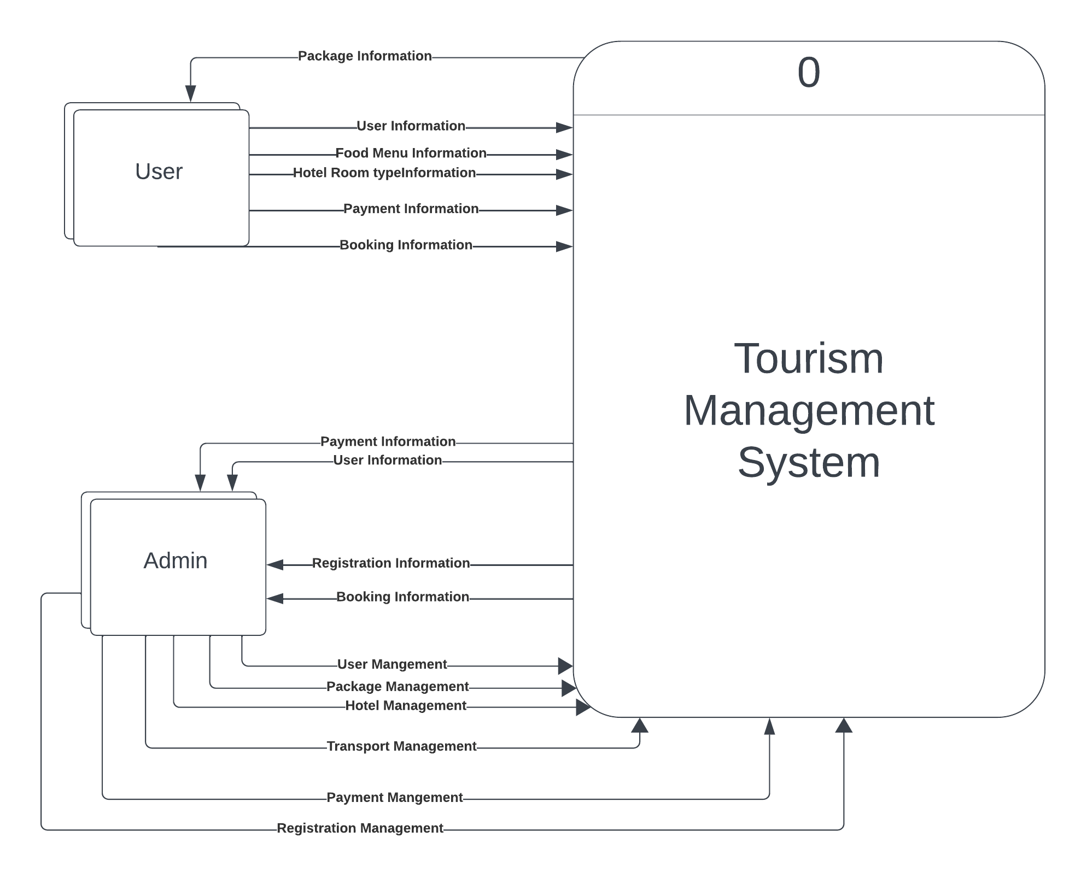

Figure 7.1 Context Level DFD

##### 7.1.2 Level 1 DFD

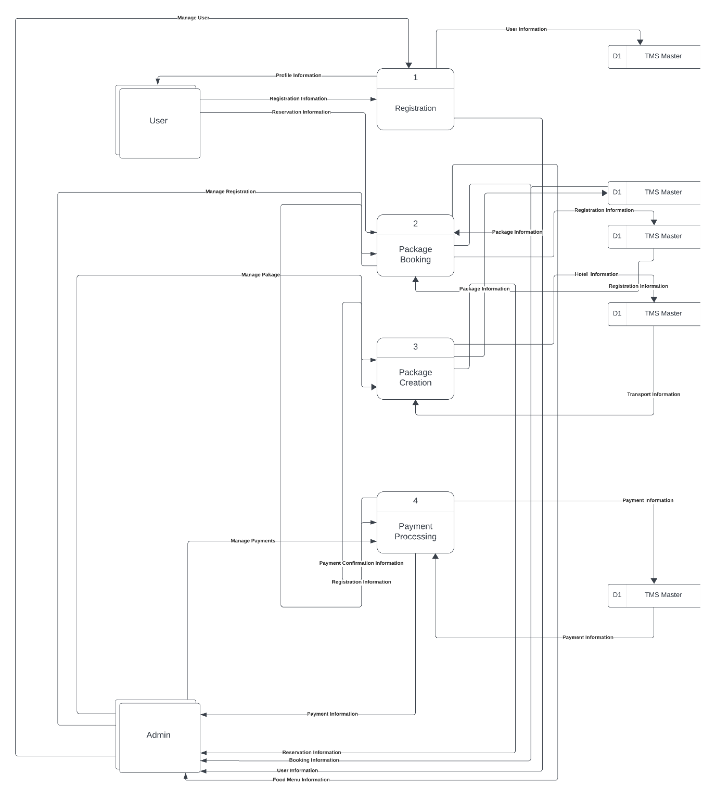

Figure 7.2 Level 1 DFD

##### 7.1.3 Level 2 Process 1 Data Flow Diagram

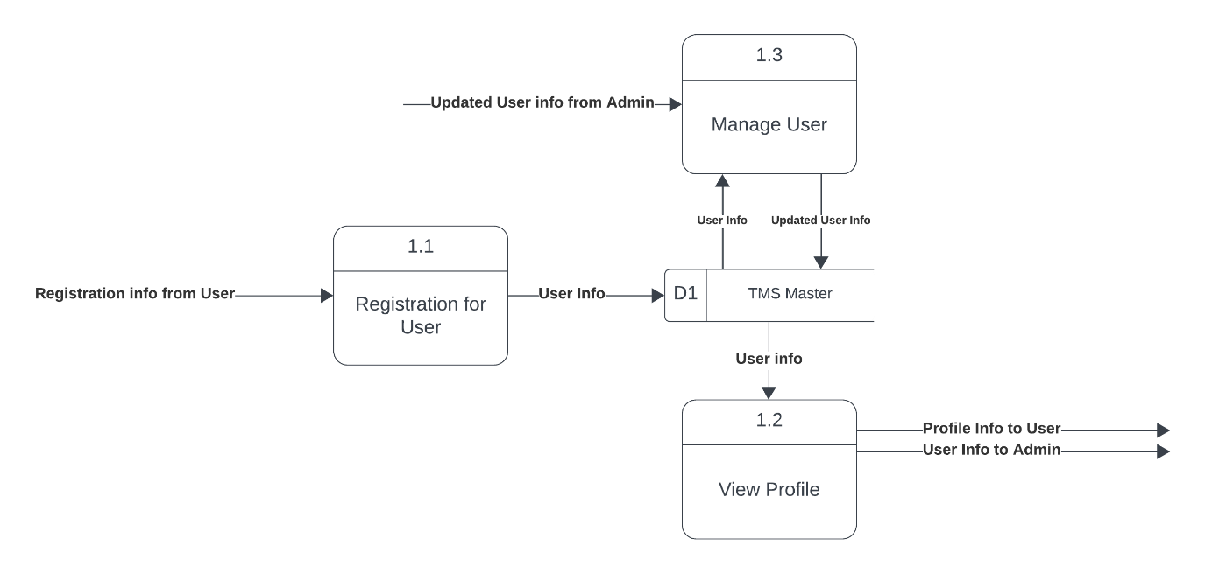

Figure 7.3 Level 2 Process 1

##### 7.1.4 Level 2 Process 2 Data Flow Diagram

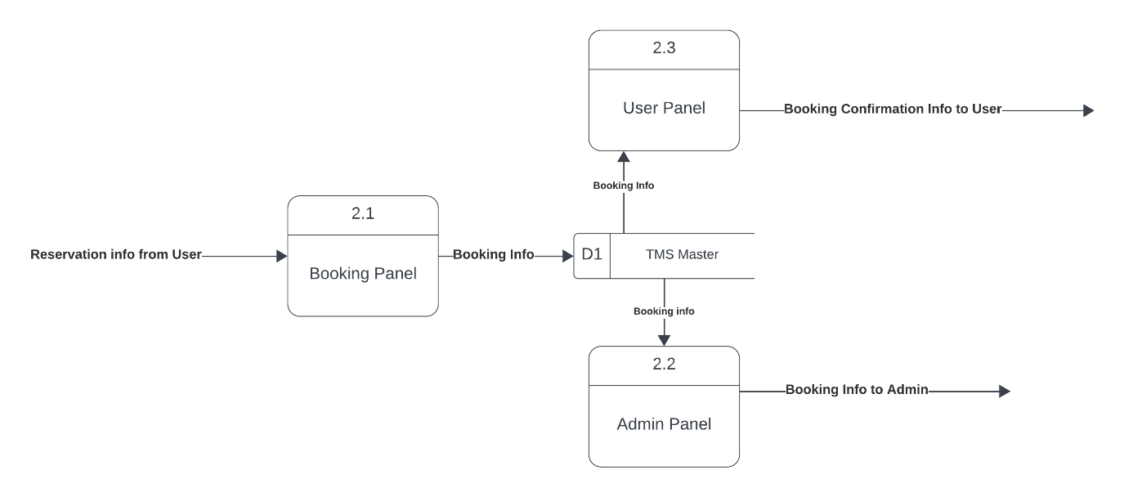

Figure 7.4 Level 2 Process 2

Figure 7.4 Level 2 Process 2

##### 7.1.5 Level 2 Process 3 Data Flow Diagram

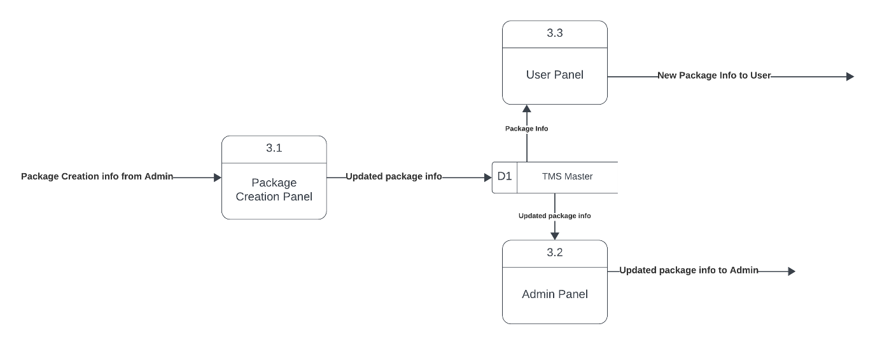

Figure 7.5 Level 2 Process 3

##### 7.1.6 Level 2 Process 4 Data Flow Diagram

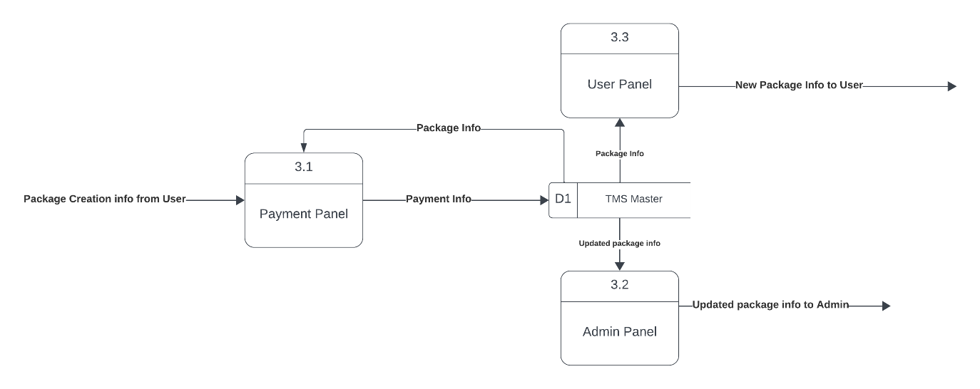

Figure 7.6 Level 2 Process 4

#### **7.2 Entity Relationship Diagram**

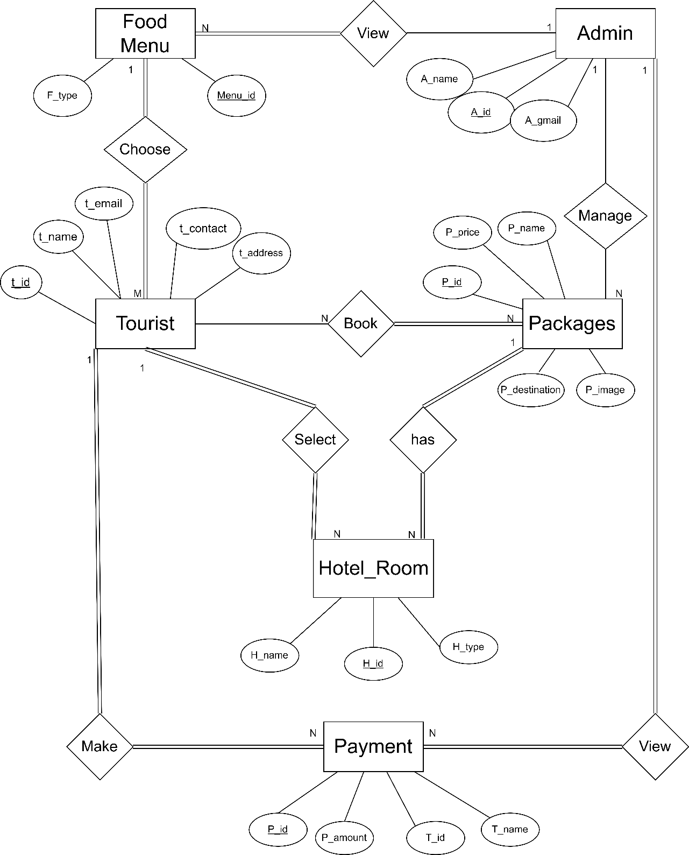

Figure 7.7 ER Diagram

#### **7.3 Database**

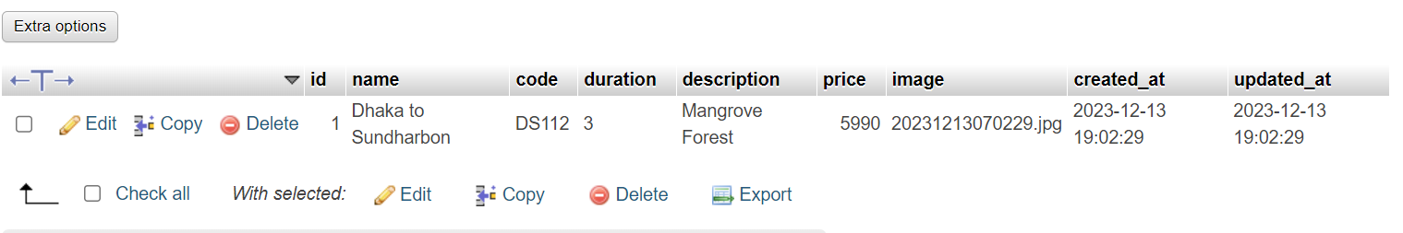

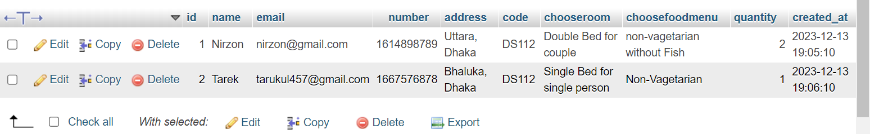Figure 7.8 Database for Package

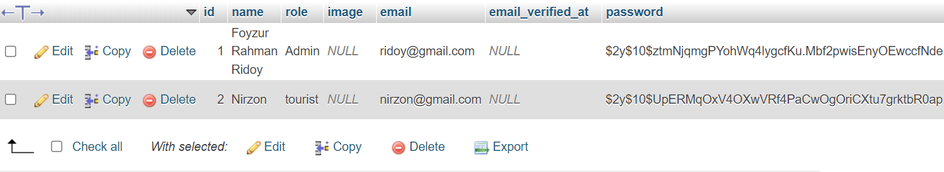Figure 7.9 Database for Tourist Booking List

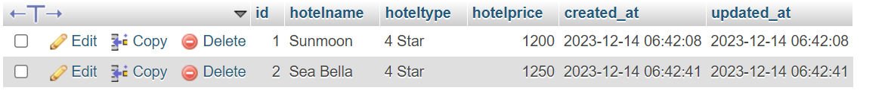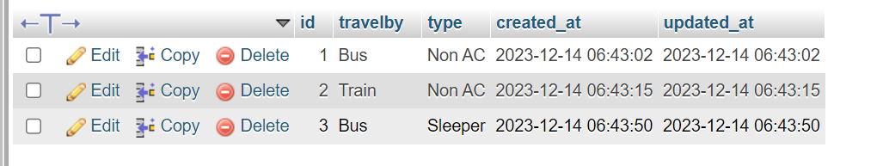

Figure 7.12 Database for Hotel Info

Figure 7.11 Database for Transport Info

Figure 7.10 Database for User Info

**7.4 Interface Design**

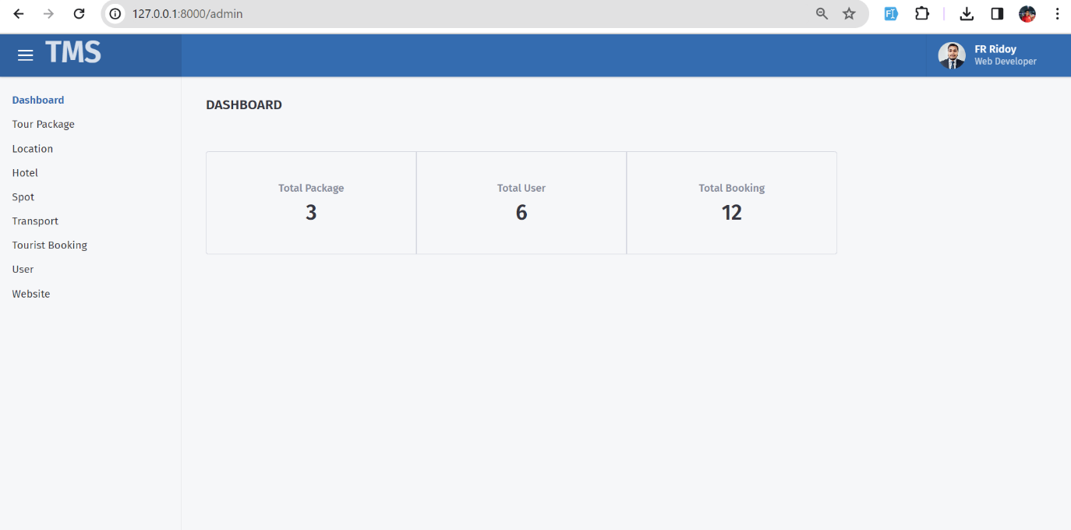

Figure 7.13 Admin Dashboard

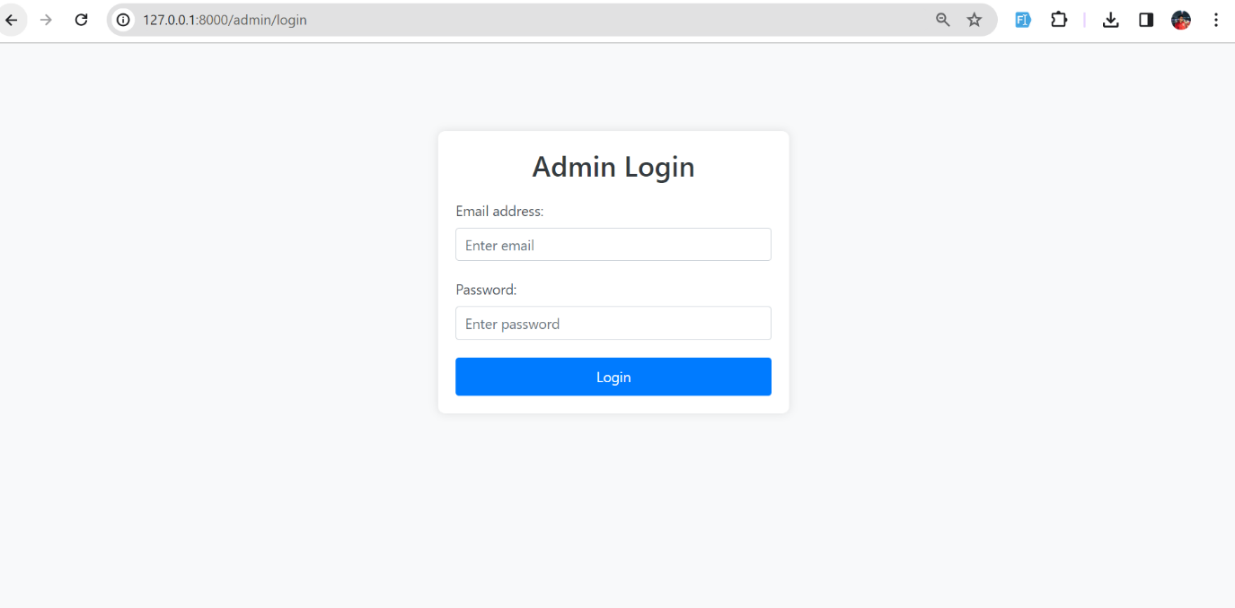

Figure 7.14 Admin Login

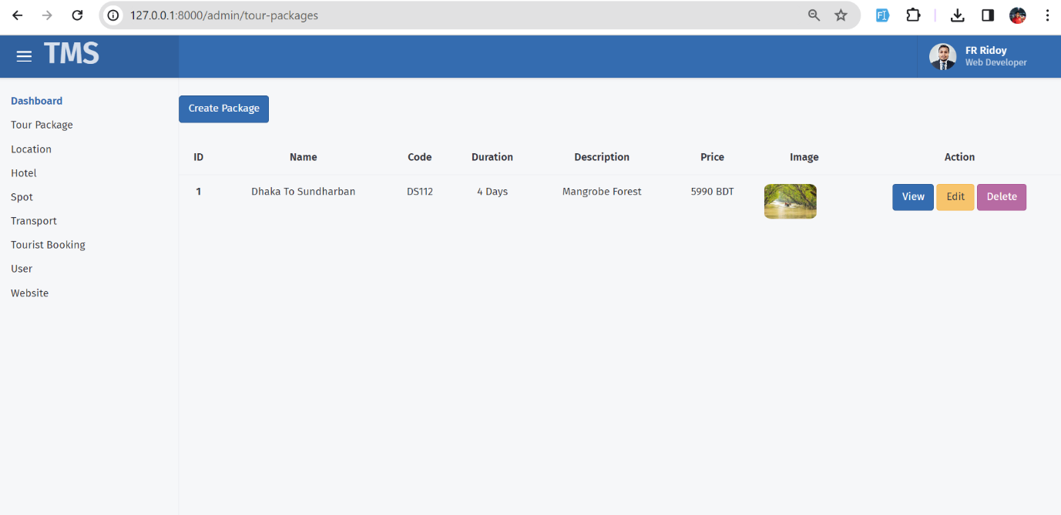

Figure 7.15 Admin Create Package

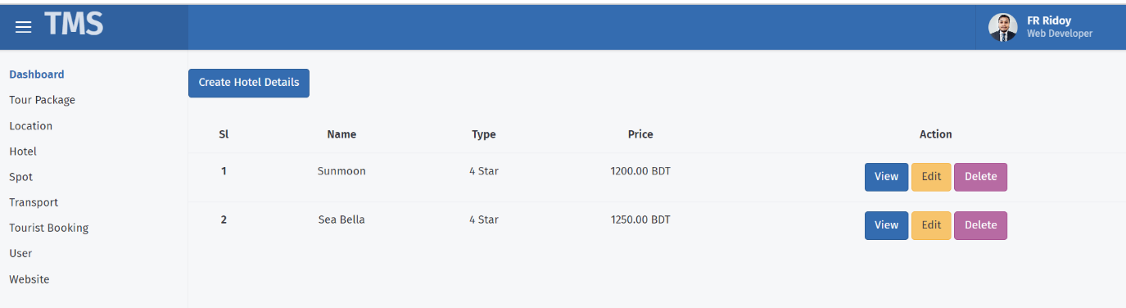

Figure 7.16 Admin Create Hotel Info

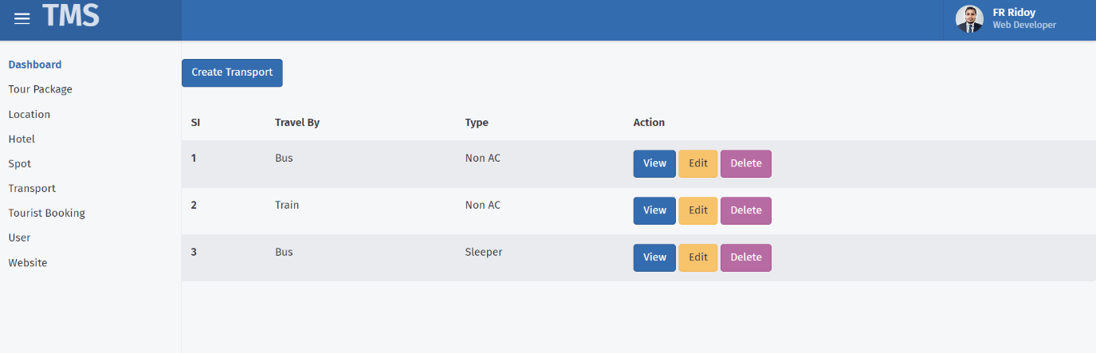

Figure 7.17 Admin Create Transport Info

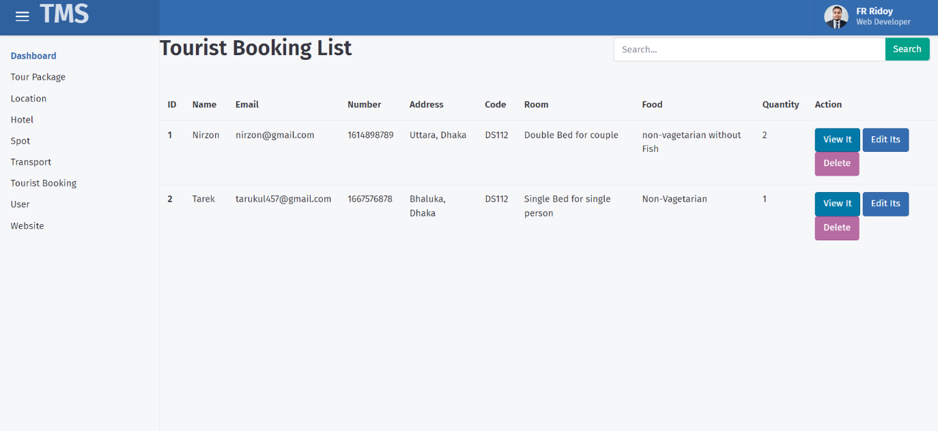

Figure 7.18 Tourist Booking List

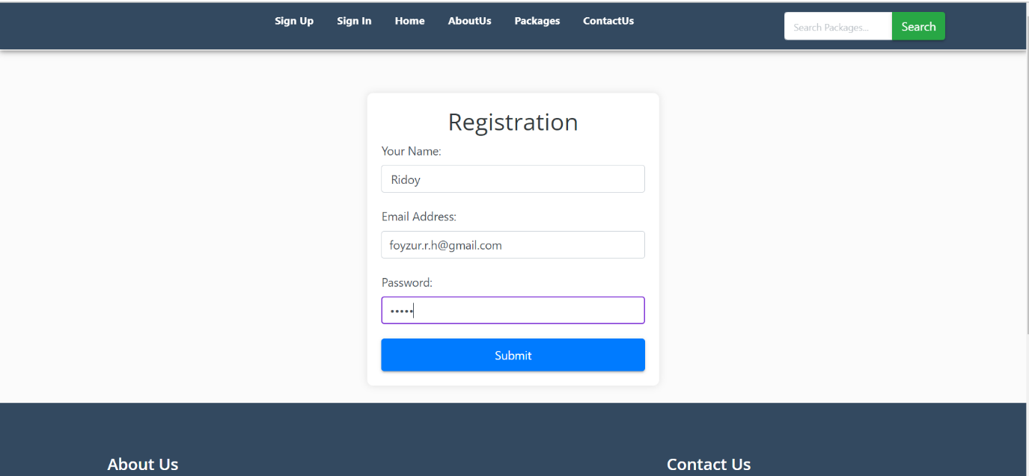

Figure 7.19 Registration form for Tourist

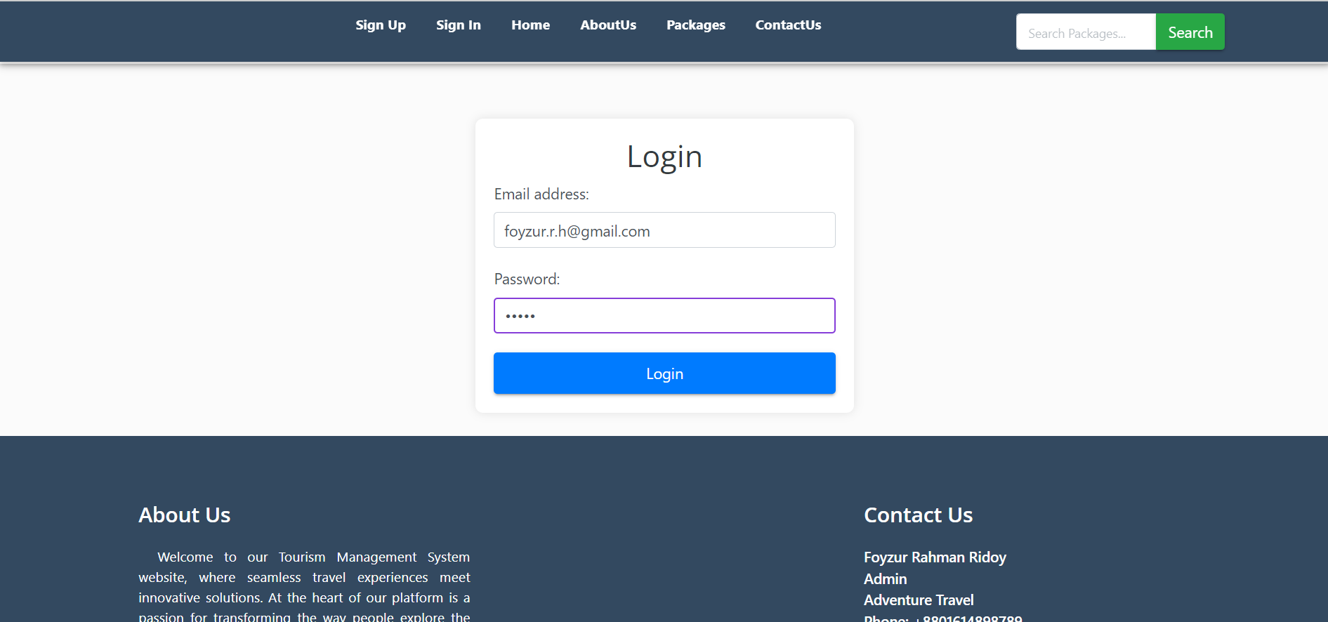

Figure 7.20 Login for Tourist



Figure 7.21 Tourist Profile

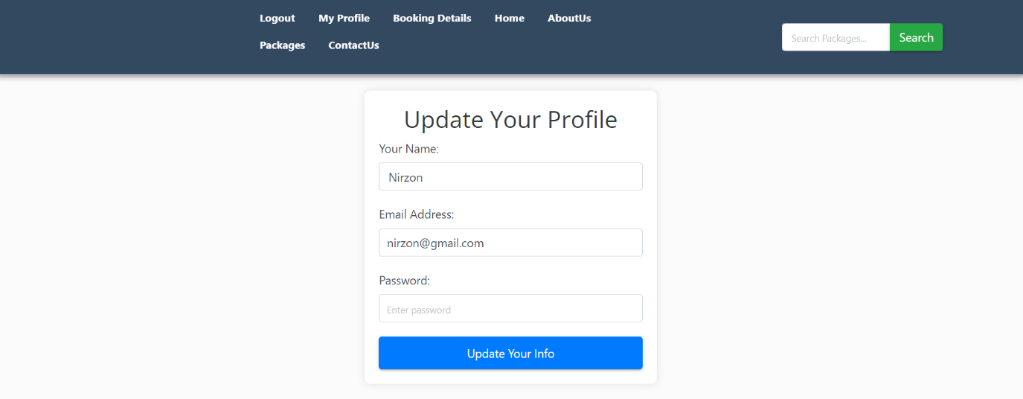

Figure 7.22 Tourist Update Profile and Password

Figure 7.23 Home Dashboard



Figure 7.24 Our Package

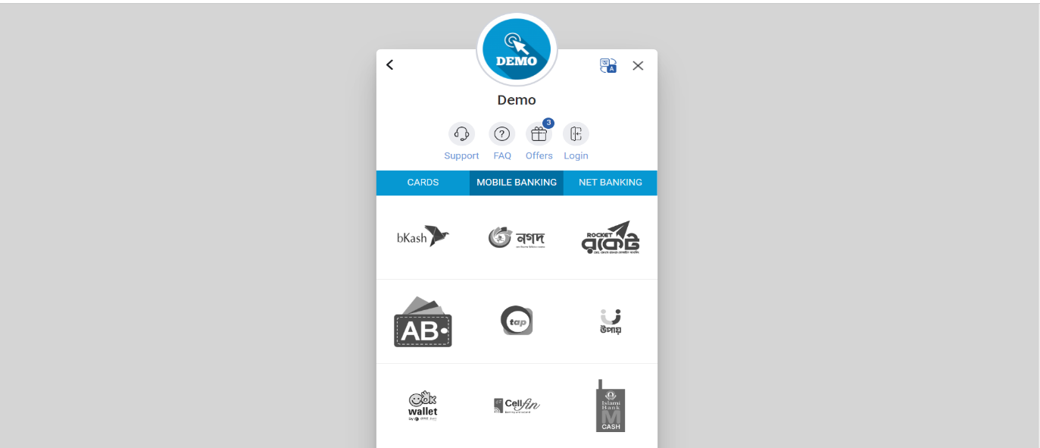

Figure 7.25 Payment

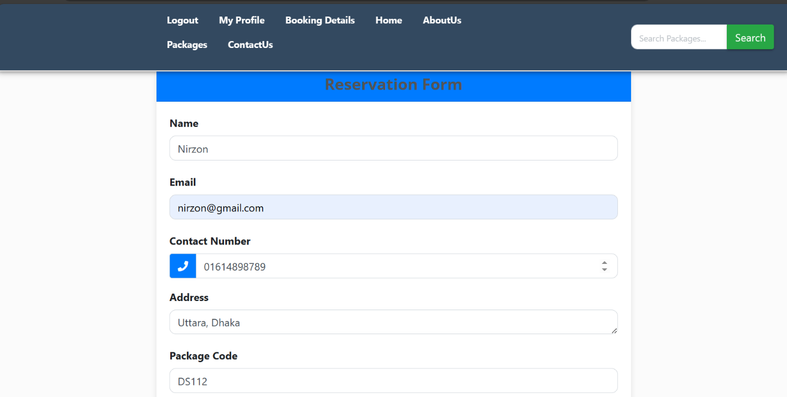

Figure 7.26 Tourist Reservation Form

## 

## **Chapter 8**

## **Quality Assurance**

#### **8.1 System Quality Management**

System test case design techniques are integral components of a well-structured software testing strategy, contributing to the efficient development of software. The strategy provides a systematic guide, delineating the steps to be followed during the testing process. Various criteria are employed to assess the software's overall quality. The user encounters the external quality of the software when utilizing it in its operational state. Elements reliant on the code and concealed from the end user constitute the internal quality. While internal quality primarily concerns developers, external quality holds paramount importance for users. Some quality standards are objectively measurable, whereas others are subjective, leading to a more arbitrary assessment. Quality standards can generally be categorized into two types.

**External quality:**

* properties
* Quickness
* Place
* Network usage
* Durability
* toughness
* Ease-of-use
* Fatalism
* Security
* Power consumption

**Internal quality:**

* Test coverage
* Testability
* Portability
* Thread-safeness
* Conciseness
* Maintainability
* Documentation
* Legibility
* Scalability

##### 8.1.1 System Quality Management Process

System quality management (SQM) aims to regulate the quality of both software development and its developmental processes. A quality product is one that aligns with the user's needs and requirements. Cultivating a culture of quality within an organization involves embracing the philosophy that quality is a collective responsibility. In the realm of Quality Assurance (QA) processes, the objective is to ensure that a project adheres to predetermined requirements, standards, and functions flawlessly without errors. QA vigilantly monitors the development process, striving for continuous improvement from the project's inception, with a primary emphasis on prevention. Verification and Validation (V&V) processes, integral to software project management, testing, and engineering, aim to confirm that a software system complies with specifications and fulfills its intended function. In this process, software testers often play a key role within the software development lifecycle. The verification phase involves scrutiny by clients or observation in a test environment, ensuring that the software meets the originally stipulated requirements. This confirmation is a crucial step before proceeding to the next stage, preventing potential issues and the need for costly upgrades. The validation phase includes client approval, systematically addressing various requirements to ensure the final product meets everyone's expectations. While this phase may seem meticulous, it is essential for guaranteeing the successful fulfillment of project objectives.

#### **8.2 System Testing**

System testing is a comprehensive approach employed to monitor and evaluate the behavior of a fully integrated software system or product in alignment with established functional criteria and requirements. The key question addressed by system testing is whether the entire system operates in accordance with its pre-defined requirements. This testing specifically focuses on assessing the external working features of the software, categorizing it as a form of system testing. Unlike other testing methods, system testing is entirely user-centered, requiring no technical expertise in coding, programming, or design. It serves as a holistic examination of the software's functionality from an end-user perspective, ensuring that the system's external aspects perform as intended and meet the specified criteria.

##### 8.2.1 System Testing Methodology

Only after undergoing numerous levels of software testing is a software product deemed ready. Every significant and minor component of the software is tested to ensure both its quality and efficacy, starting with its internal structure and code and continuing through to its fundamental features, functionality, performance, and more. Two Category of Software Testing:

* Black Box Testing
* White Box Testing

**Black Box Testing:** Black-box testing, also known as behavioral testing, is a method focused on the functional requirements of software. In this approach, the software engineer does not have access to the internal code, algorithms, or implementation details. Instead, the testing is conducted by providing inputs and observing outputs, emphasizing the examination of the software's external behavior.

**White Box Testing:** White-box testing, often referred to as glass-box testing, is a test case design technique that involves deriving test cases from the procedural design's control structure. In white-box testing, the tester has access to the internal code, logic, and implementation details of the software. The objective is to create test cases that thoroughly examine the internal workings of the software.

Put all logical conclusions into action on both their true and false sides.

To comprehensively test modules containing complex calculations or decision-making code, particularly in scenarios such as checking the availability of a library item, a white-box approach is employed. The following strategies are utilized within white-box testing to ensure thorough testing:

#### **8.3 System Testing Design**

Table 8.1 System Testing Scenario 1

|  |  |
| --- | --- |
| Scenario | Tourist Login testing scenario of my system |
| Input’s | E-mail and password of Tourist for login |
| Desired Output’s | When e-mail and password are entered get access level  define |
| Actual Output’s | For login my system works correctly |
| Verdict | This system is successful for login because it yields results from planned outputs and actual outputs determined based on user roles. |

Table 8.2 System Testing Scenario 2

|  |  |
| --- | --- |
| Scenario | Admin can view/delete Tourist |
| Input’s | Admin crud info needed |
| Desired Output’s | When Admin provides crud info it will provide view or delete the user. |
| Actual Output’s | Admin can perform crud operation. |
| Verdict | Finding the difference between desired and actual outputs determined this system's success for a new user. |

Table 8.3 System Testing Scenario 3

|  |  |
| --- | --- |
| Scenario | Admin can check payments |
| Input’s | Admin crud command for checking payments history |
| Desired Output’s | When admin performs crud operation, he can see the recent transactions. |
| Actual Output’s | My system can provide view of payments to Admin |
| Verdict | This technique is successful for viewing payments based on the results of desired and actual outputs. |

Table 8.4 System Testing Scenario 4

|  |  |
| --- | --- |
| Scenario | User can create profile |
| Input’s | User input for profile information |
| Desired Output’s | When all required info entered correctly, after process, user will be registered for the desired profile |
| Actual Output’s | For user registration, my system works correctly |
| Verdict | Finding the correlation between desired and actual outputs determined the donation success of this system. |

Table 8.5 System Testing Scenario 5

|  |  |
| --- | --- |
| Scenario | Admin can create a Package |
| Input’s | Package Details for package creation |
| Desired Output’s | When all required info entered correctly, a new package will be created in the system. |
| Actual Output’s | For creating new packages, my system works correctly. |
| Verdict | Finding the difference between desired and actual outputs determined whether this method was successful for package list. |

Table 8.6 System Testing Scenario 6

|  |  |
| --- | --- |
| Scenario | Tourists can search for packages |
| Input’s | Tourist will search with a keyword |
| Desired Output’s | When all required info entered correctly, search result will come |
| Actual Output’s | For searching packages, my system works correctly |
| Verdict | Obtaining results based on anticipated and actual outputs  decided that this search system works well. |

## **Chapter 9**

## **Conclusion**

Every corporate sector and the educational system operate entirely digitally in today's environment. Therefore, we must improve the accuracy and effectiveness of their method. I'm hoping that this advancement will benefit them.

#### **9.1 Project limitation**

A significant limitation of the Tourism Management System lies in its reliance on internet connectivity. Given that the system is primarily designed to function in an online environment, users may encounter challenges related to functionality and accessibility when reliable internet connectivity is unavailable or unstable. This dependency on the internet may prove to be particularly limiting for users in remote areas with limited connectivity or during events held in locations with unreliable network infrastructure. The nature of the Tourism Management System involves an intricate process where the administrator creates packages containing essential information such as hotel details and transport information. Subsequently, tourists access these packages, review available options, and select hotel room types and food menus before making a payment to finalize their bookings.

#### **9.2 Future work**

The commitment to advancing the Tourism Management System persists, with a focus on continuous development in the future. To enhance the system's usability and broaden its capabilities, the plan is to introduce several additional modules catering to various aspects of tourism management.

#### **9.3 Conclusion**

In conclusion, the Tourism project has been an enriching journey aimed at redefining the landscape of tourism management. Through the application of advanced web development skills, I have effectively addressed significant challenges prevalent in traditional tourism management systems. The primary focus has been on providing a seamless platform that allows users to explore, select, and book diverse tourism packages, emphasizing our commitment to enhancing accessibility and user experience.

By integrating insightful analytics and introducing a dedicated admin dashboard, Tourism aspires to revolutionize conventional tourism management. The system aims not only to streamline the booking process but also to cater to a wide range of user preferences and technological proficiencies. This transformative approach underscores the potential of web development in shaping a future where tourism management is not just efficient and transparent but also tailored to individual needs.

The Tourism project serves as a pivotal moment at the intersection of technology and tourism coordination, setting the stage for a future where innovation continues to redefine and elevate the standards of organizing and participating in diverse tourism experiences. As we embrace the transformative power of technology, the project envisions a future where tourism management becomes more intuitive, user-friendly, and adaptable, providing a seamless and enriching experience for both tourists and administrators alike.

## **References**

GeeksforGeeks. (2023). Retrieved from https://www.geeksforgeeks.org/system-testing/

Google Maps. (2023). *Kodeeo Location*. Retrieved from https://www.google.com/maps/place/Kodeeo+Limited/@23.8789322,90.3886144,17z/data=!3m1!4b1!4m6!3m5!1s0x3755c66fa327665d:0xbfd47517eb3e2224!8m2!3d23.8789273!4d90.3911893!16s%2Fg%2F11bwqbwq_p?entry=ttu

Kodeeo. (2023). Retrieved from https://www.kodeeo.com/#about-us

Wei, W. (2012). Research on the Application of Geographic Information System in Tourism Management. *Procedia Environmental Sciences*, 12, pp.1104–1109. doi:https://doi.org/10.1016/j.proenv.2012.01.394.

Law, R., Qi, S. and Buhalis, D. (2010). Progress in tourism management: A review of website evaluation in tourism research. *Tourism Management*, 31(3), pp.297–313. doi:https://doi.org/10.1016/j.tourman.2009.11.007.

FROLOVA, V.B., AVRAMENKO, G.M., BESKOROVAYNAYA, S.A., SHELYGOV, A.V. and MATYUNINA, O.E. (2019). Digital Economy in the Management System of Tourism Enterprises. *Journal of Environmental Management and Tourism*, 10(6), p.1345. doi:https://doi.org/10.14505//jemt.v10.6(38).17.